



**Software Requirement Specification (SRS)**

Of

**HRMS Module**

**Masters**

**&**

**Recruitment**

For Implementation of

**Campus Management Software**

at

**World Skill Center (WSC)**

**Sustainable Outreach And Universal**

**Leadership (SOUL) Limited**

**Content**

A. Abstract 3

B. Introduction 3

C. Definition, Acronyms and Abbreviations 3

D. Overview of the Document 3

E. Scope of HRMS Module 4

F. List of Screens and their descriptions 4

G. Process Definition and Requirements 6

1. Masters 6

1.1 Department 6

1.2 Branch 8

1.3 Designation 9

1.4 Employment Type 11

1.5 Employee Grade 12

1.6 Employee Health Insurance 13

1.7 Category 14

1.8 Employee 15

1.9 Employee Group 24

1.10 HR Settings 26

2. Recruitment 29

2.1 Center Selection Master 30

2.2 Interview Type 32

2.3 Interview Round 33

2.4 Job Requisition 35

2.5 Staffing Plan 37

2.6 Job Opening 39

2.7 Job Applicant 41

2.8 Recruitment Exam Declaration 45

2.9 Recruitment Exam Center Allocation 47

2.10 Recruitment Exam Admit Card Generation Tool 49

2.11 Recruitment Exam Admit Card Generation 52

2.12 Recruitment Exam Result Declaration Tool 53

2.13 Recruitment Exam Result Declaration 55

2.14 Interview 56

2.15 Job Offer 59

2.16 Appointment Letter Template 61

2.17 Appointment Letter 62

# Abstract

Software Requirements Gathering is one of the first phases of system development. This phase results in the Software Requirements Specification (SRS) document, which must contain a complete, concise, high-quality description of the system being considered.

# Introduction

The World Skill Center (WSC) is a premier advanced skill training institute established by the Government of Odisha, Skill Development and Technical Education Department, through the Odisha Skill Development Authority (OSDA). The WSC will impart advanced skill training in eight trades from engineering and service sectors. WSC caters primarily to induct the best talent from ITIs and Polytechnics and train them to become globally employable in emerging areas such as "Industry 4.0". WSC is housed in a state-of-the-art, 18-storey, air-conditioned building with nearly half a million square feet of space in the heart of capital city of Bhubaneswar.

With the Implementation of campus management software for WSC the goal is to streamline the operations and functions of the campus by integrating various processes, such as admissions, course registration, academic progress tracking, and financial management, HRMS, Procurement and Inventory management, etc into a unified system. The implementation also aims at providing a user-friendly interface for all stakeholders, making it easier for them to access the necessary information and complete their tasks with ease. The modules to be covered during the implementation of the software includes:

|  |  |
| --- | --- |
| Students Management Modules | Infrastructure Management |
| Academic System | Finance and Accounting System |
| Procurement & Inventory Management | Training and Placement |
| Human Resources Management System | Application Integration |

# Definition, Acronyms and Abbreviations

The following table explains the terms and abbreviations used in the document:

|  |  |
| --- | --- |
| **Abbreviation** | **Description** |
| SRS | Software Requirements Specification |
| HRMS | Human Resource Management System |
| R | Rename - When a field is Renamed |
| N | New - When a New field is Added |
| D | Delete - When an Existing field is Deleted |
| NA | Not Applicable |

# Overview of the Document

This requirement document provides a detailed overview of the functional requirements of a project. It serves as a communication tool between stakeholders, including developers, project managers, and end-users. The purpose of this requirement document is to define and document the project's objectives, scope, and expectations, and to ensure that all stakeholders have a clear understanding of what the project entails.

This document covers all the functional requirements of the sub modules o**f HRMS** including **Masters and Recruitment process**. This module helps in organizing the generic masters form like Employee,Employment type which are the per-requisites for the overall transaction.It also consist of Recruitment process starting from Job Requisition to Appointment.

# Scope of HRMS Module

* Recruitment process management
* Employee Lifecycle including Employee boarding,promotion,transfer,retirements,separation and re-engagement of employee.
* Staff profile management including Educational qualification,work experience,work history and so on.
* Attendance Management
* Grievance and Disciplinary cases monitoring.
* Performance Management System.
* Leave management
* Shift Management

Following functionalities are covered in this SRS document:

* **Masters**
* **Recruitment Process**
* **Staff Profile Management(Personal Details,Contact Details,Educational Qualification,Work History)**

▪

# List of Screens and their descriptions

The following screens are present in masters and recruitment sub modules :

|  |  |  |
| --- | --- | --- |
| **Sl no** | **Existing Application** **Screen Name** | **Description** |
| Masters | | |
| 1 | Department | A Department is a specialized functional area or a division within an organization. |
| 2 | Branch | A Branch office is an outlet of a company located at a different location, other than the main office. |
| 3 | Designation | Designations are the official job titles given to employees. |
| 4 | Employment Type | Employment Type is to employ people under a number of categories each having their own wage and leave entitlements. |
| 5 | Employee Grade | An Employee Grade is a grouping of the employees with similar positions or values in order to assign compensation rates and salary structures. |
| 6 | Employee Health Insurance | Employee Health Insurance is a benefit extended by the company to their employees. |
| 7 | Category | Category helps the users to define different types of employee like PWD,ex-serviceman and so on. |
| 8 | Employee | Employee is an individual who works part-time or full-time under a contract of employment, and has recognized rights and duties of your company. |
| 19 | Employee Group | Employee Group is grouping of Employees based on some attributes such as Designation, Grade, Branch, etc. |
| 10 | HR Settings | HR Settings allow global settings for HR-related documents. |
| Recruitment | | |
| 11 | Center Selection Master | A master screen where basic information regarding a exam centre is stored. |
| 12 | Interview Type | Interview Type form helps you to define different kinds of interview like HR Interview,Technical Interview and so on. |
| 13 | Interview Round | Interview round will consist of different interview round along with other interview details like skills and expected ratings and so on. |
| 14 | Job Requisition | A job requisition is a formal request recruiters or hiring managers fill out for their company's HR department to create a new position or to fill a job vacancy. |
| 15 | Staffing Plan | Staffing Plan helps you to plan manpower requirements for your Company. |
| 16 | Job Opening | A Job Opening is a job vacancy in your Company. You can make a record of the open vacancies in your company using Job Opening. |
| 17 | Job Applicant | A Job Applicant Screen is the screen in which a person can able to apply for a job in your Company against a particular Job Opening. |
| 18 | Recruitment Exam Declaration | A screen where information regarding recruitment exams. |
| 19 | Recruitment Exam Center Allocation | A Recruitment Exam Center Allocation consist of the information regarding exam location and date for the entrance exam is to be allotted and stored. |
| 20 | Recruitment Exam Admit Card Generation Tool | A Recruitment Exam Admit Card Generation tool to generate multiple admit cards for applicants and also allots them a venue for the exam. |
| 21 | Recruitment Exam Admit Card Generation | A Recruitment Exam Admit Card Generation screen which holds information of an individual job applicants admit card. |
| 22 | Interview | Interview screen schedule the interview for candidates and also the feedback of the interview. |
| 23 | Recruitment Exam Result Declaration Tool | A Recruitment Exam Result Declaration Tool declares the result of the applicant for different exam round in bulk. |
| 24 | Recruitment Exam Result Declaration | A Recruitment Exam Result Declaration Tool declares the result of the applicant for different exam round for particular candidate. |
| 25 | Job Offer | Job Offer is given to selected candidates after interview and selection which states the offered salary package, designation, grade, department, number of days entitled for leave among other information. |
| 26 | Appointment Letter Template | Appointment Letter Template is the standardized template used as the content of the appointment letter. |
| 27 | Appointment Letter | Appointment Letter is the letter written by the employer requesting the selected candidates to join in a specific position. |

# Process Definition and Requirements

## Masters

Master Data is the central database used to define entities so that there is standardization and uniformity across the organization.These are the per-requisites for the further transactional processes.

### Department

**General Description**

The following table describes overall information about this screen:

|  |  |  |
| --- | --- | --- |
| **Description** | | 1. A Department is a specialized functional area or a division within an organization. 2. User will configure the Departments, set Leave Block List and also Leave and Expense Approvers for the same. 3. Department is a tree-structured master, which means user can create parent departments and sub-departments as shown below |
| **Navigation** | Home > HRMS > Employee > Department | |
| **Pre-requisites** | The system should have records in the following screen   1. Company 2. Leave Block List | |
| **Existing Screen Name** | Department | |
| **New Screen Name** | No change | |

**Screenshot**

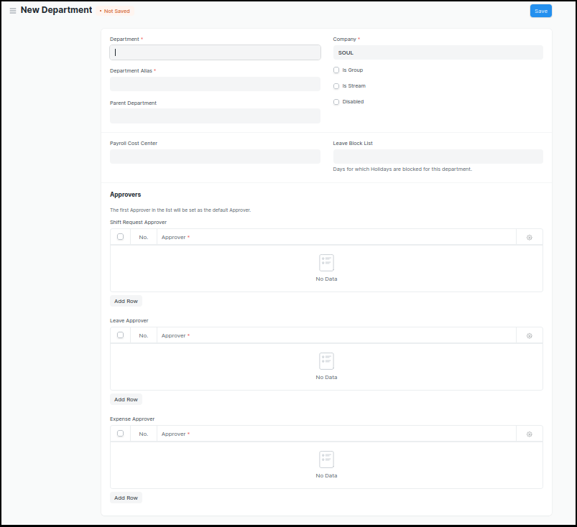

Figure 1:Department Screen

**Field List**

The following table describes the UI fields present in this screen :

|  |  |  |  |  |  |  |
| --- | --- | --- | --- | --- | --- | --- |
| **ID** | **Label** | **Type** | **Mandatory** | **Validation/ Action** | **Remarks** | **R = Rename**  **N= New**  **D= Delete** |
| 1 | Department | Text | Yes |  |  |  |
| 2 | Parent Department | Link |  |  |  |  |
| 3 | Company | Link | Yes | Link Fields to Master Screen Company | Default company name will be fetched |  |
| 4 | Is Group | Checkbox |  | If checked the department will be grouped under a parent department |  |  |
| 5 | Is Stream | Checkbox |  | If checked the department will be considered as a stream E.g (Commerce, Arts, Etc) |  |  |
| 6 | Disabled | Checkbox |  | If checked, the department record will not be able to visible in any transaction |  |  |
| 7 | Payroll Cost Center | Link |  | Link Fields to Account’s Master Screen Cost Center |  |  |
| 8 | Leave Block List | Link |  | Link Fields to Master Screen Leave Block List |  |  |
| 10 | Shift Request Approver | Table |  |  | This table is described below |  |
| 11 | Leave Approver | Table |  |  | This table is described below |  |
| 12 | Expense Approver | Table |  |  | This table is described below |  |
| Shift Request Approver | | | | | | |
| **ID** | **Label** | **Type** | **Mandatory** | **Validation/ Action** | **Remarks** | **R = Rename**  **N= New**  **D= Delete** |
| 1 | Approver | Link | Yes | Link Field to Master Screen “User” | The first approver in the list will be set as the default Approver |  |
| Leave Approver | | | | | | |
| **ID** | **Label** | **Type** | **Mandatory** | **Validation/ Action** | **Remarks** | **R = Rename**  **N= New**  **D= Delete** |
| 1 | Approver | Link | Yes | Link Field to Master Screen “User” | The first approver in the list will be set as the default Approver |  |
| Expense Approver | | | | | | |
| **ID** | **Label** | **Type** | **Mandatory** | **Validation/ Action** | **Remarks** | **R = Rename**  **N= New**  **D= Delete** |
| 1 | Approver | Link | Yes | Link Field to Master Screen “User” | The first approver in the list will be set as the default Approver |  |

**Users: Roles & Permission**

The following table describes the users and their roles and permissions for the screens :

|  |  |  |  |  |  |  |  |  |  |
| --- | --- | --- | --- | --- | --- | --- | --- | --- | --- |
| **ID** | **Role** | **Select** | **Read** | **Write** | **Create** | **Delete** | **Submit** | **Cancel** | **Amend** |
| 1 | HR Admin/Director Admin | Yes | Yes | Yes | Yes | Yes | NA | NA | NA |
| 2 | HR Manager/CS | No | Yes | Yes | Yes | No | NA | NA | NA |
| 3 | HR Assistant | No | Yes | No | No | No | NA | NA | NA |
| 4 | Employee | No | Yes | No | No | No | NA | NA | NA |

### Branch

**General Description**

The Following table describe overall information about this screen:

|  |  |  |
| --- | --- | --- |
| **Description** | | 1. Branch consist list of different locations of a company. |
| **Navigation** | Home > HRMS> Employee > Branch | |
| **Pre-requisites** | The system should have records in the following screen:   1. Company | |
| **Existing Screen Name** | Branch | |
| **New Screen Name** | No change | |

**Screenshot**

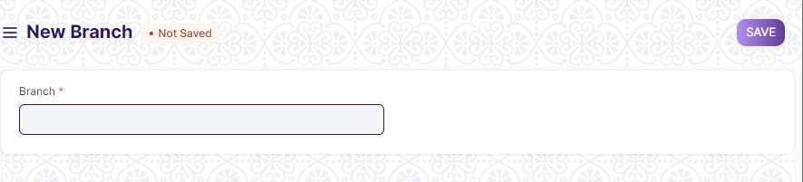

Figure 2:Branch Screen

**Field List**

The following table describes the UI fields present in this screen :

|  |  |  |  |  |  |  |
| --- | --- | --- | --- | --- | --- | --- |
| **ID** | **Label** | **Type** | **Mandatory** | **Validation/ Action** | **Remarks** | **R = Rename**  **N= New**  **D= Delete** |
| 1 | Branch | Text | Yes |  | Set the name or location of the branch |  |

**Users: Roles & Permission**

The following table describes the users and their roles and permissions for the screens :

|  |  |  |  |  |  |  |  |  |  |
| --- | --- | --- | --- | --- | --- | --- | --- | --- | --- |
| **ID** | **Role** | **Select** | **Read** | **Write** | **Create** | **Delete** | **Submit** | **Cancel** | **Amend** |
| 1 | HR Admin/Director Admin | Yes | Yes | Yes | Yes | Yes | NA | NA | NA |
| 2 | HR Manager/CS | No | Yes | Yes | Yes | No | NA | NA | NA |
| 3 | HR Assistant | No | Yes | No | No | No | NA | NA | NA |
| 4 | Employee | No | Yes | No | No | No | NA | NA | NA |

### Designation

**General Description**

The Following table describe overall information about this screen:

|  |  |  |
| --- | --- | --- |
| **Description** | | 1. Designations are the official job titles given to   employees.   1. User can create various designations and also   mention the skills required for the same. |
| **Navigation** | Home > HRMS> Employee > Designation | |
| **Pre-requisites** | The system should have records in the following screen:   1. Company | |
| **Existing Screen Name** | Designation | |
| **New Screen Name** | No change | |

**Screenshot**

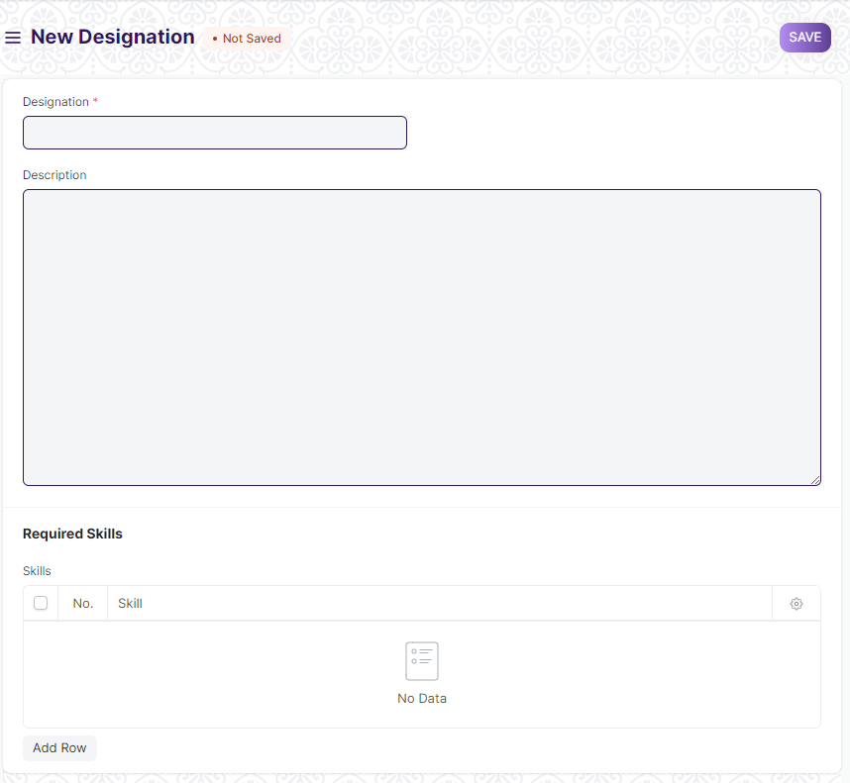

Figure 3 : Designation Screen

**Field List**

The following table describes the UI fields present in this screen :

|  |  |  |  |  |  |  |
| --- | --- | --- | --- | --- | --- | --- |
| **ID** | **Label** | **Type** | **Mandatory** | **Validation/ Action** | **Remarks** | **R = Rename**  **N= New**  **D= Delete** |
| 1 | Designation | Text | Yes |  | Set the name of the designation |  |
| 2 | Description | Text |  |  |  |  |
| 3 | Skills | Table |  |  | This table is described below |  |
| Skills | | | | | | |
| **ID** | **Label** | **Type** | **Mandatory** | **Validation/ Action** | **Remarks** | **R = Rename**  **N= New**  **D= Delete** |
| 1 | Skill | Link |  | Link Field to Master Screen “Skill” | The first approver in the list will be set as the default Approver |  |

**Users: Roles & Permission**

The following table describes the users and their roles and permissions for the screens :

|  |  |  |  |  |  |  |  |  |  |
| --- | --- | --- | --- | --- | --- | --- | --- | --- | --- |
| **ID** | **Role** | **Select** | **Read** | **Write** | **Create** | **Delete** | **Submit** | **Cancel** | **Amend** |
| 1 | HR Admin/Director Admin | Yes | Yes | Yes | Yes | Yes | NA | NA | NA |
| 2 | HR Manager/CS | No | Yes | Yes | Yes | No | NA | NA | NA |
| 3 | HR Assistant | No | Yes | No | No | No | NA | NA | NA |
| 4 | Employee | No | Yes | No | No | No | NA | NA | NA |

### Employment Type

**General Description**

The Following table describe overall information about this screen:

|  |  |  |
| --- | --- | --- |
| **Description** | | 1. Employment Type is to employ people under   a number of categories each having their own  wage and leave entitlements such as:   1. Intern 2. Full-time 3. Part-time 4. Deputation 5. Contractual |
| **Navigation** | Home > HRMS> Employee > Employment Type | |
| **Pre-requisites** | The system should have records in the following screen:   1. Company | |
| **Existing Screen Name** | Employment Type | |
| **New Screen Name** | No change | |

**Screenshot**

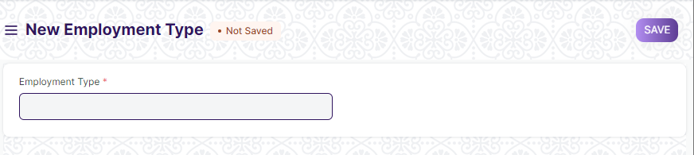

Figure 4 : Employment Type Screen

**Field List**

The following table describes the UI fields present in this screen :

|  |  |  |  |  |  |  |
| --- | --- | --- | --- | --- | --- | --- |
| **ID** | **Label** | **Type** | **Mandatory** | **Validation/ Action** | **Remarks** | **R = Rename**  **N= New**  **D= Delete** |
| 1 | Employment Type | Text | Yes |  | Set the name/type of the employment |  |

**Users: Roles & Permission**

The following table describes the users and their roles and permissions for the screens :

|  |  |  |  |  |  |  |  |  |  |
| --- | --- | --- | --- | --- | --- | --- | --- | --- | --- |
| **ID** | **Role** | **Select** | **Read** | **Write** | **Create** | **Delete** | **Submit** | **Cancel** | **Amend** |
| 1 | HR Admin/Director Admin | Yes | Yes | Yes | Yes | Yes | NA | NA | NA |
| 2 | HR Manager/CS | No | Yes | Yes | Yes | No | NA | NA | NA |
| 3 | HR Assistant | No | Yes | No | No | No | NA | NA | NA |
| 4 | Employee | No | No | No | No | No | NA | NA | NA |

### Employee Grade

**General Description**

The Following table describe overall information about this screen:

|  |  |  |
| --- | --- | --- |
| **Description** | | 1. Employee Grade is a grouping of the employees with similar positions or values in order to assign compensation rates and salary structures. 2. Users can configure Employee Grades that helps user to fetch employee record in bulk based on their grades while processing payroll,allocating leaves and so on. |
| **Navigation** | Home > HRMS> Employee > Employee Grade | |
| **Pre-requisites** | The system should have records in the following screen:   1. Leave Policy 2. Salary Structure | |
| **Existing Screen Name** | Employee Grade | |
| **New Screen Name** | No change | |

**Screenshot**

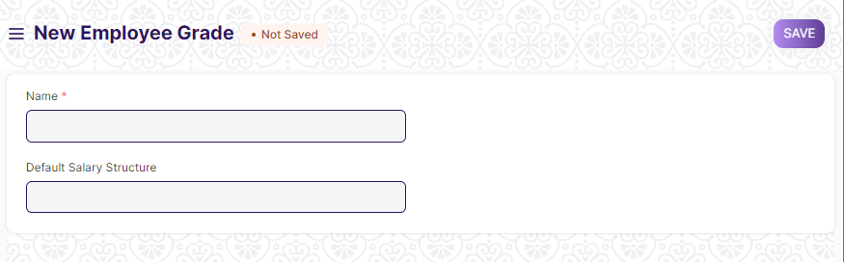

Figure 5 : Employee Grade Screen

**Field List**

The following table describes the UI fields present in this screen :

|  |  |  |  |  |  |  |
| --- | --- | --- | --- | --- | --- | --- |
| **ID** | **Label** | **Type** | **Mandatory** | **Validation/ Action** | **Remarks** | **R = Rename**  **N= New**  **D= Delete** |
| 1 | Name | Text | Yes |  | Set the name of the Employee Grade |  |
| 2 | Default Salary Structure | Link |  | Link Field to screen “Salary Structure” |  |  |
| 3 | Default Base Pay | Currency |  | Depends on the “Default Salary Structure”.Base Pay field will be auto-populated as per the salary structure selected. |  |  |

**Users: Roles & Permission**

The following table describes the users and their roles and permissions for the screens :

|  |  |  |  |  |  |  |  |  |  |
| --- | --- | --- | --- | --- | --- | --- | --- | --- | --- |
| **ID** | **Role** | **Select** | **Read** | **Write** | **Create** | **Delete** | **Submit** | **Cancel** | **Amend** |
| 1 | HR Admin/Director Admin | Yes | Yes | Yes | Yes | Yes | NA | NA | NA |
| 2 | HR Manager/CS | No | Yes | Yes | Yes | No | NA | NA | NA |
| 3 | HR Assistant | No | Yes | No | No | No | NA | NA | NA |
| 4 | Employee | No | No | No | No | No | NA | NA | NA |

### Employee Health Insurance

**General Description**

The Following table describe overall information about this screen:

|  |  |  |
| --- | --- | --- |
| **Description** | | 1. Employee Health Insurance is a benefit extended by the company to their employees. When a company provides health insurance assistance, they pay full or part premiums for the health insurance policy. 2. User can save and link it to that particular Employee’s master. |
| **Navigation** | Home > HRMS> Employee > Employee Health Insurance | |
| **Pre-requisites** | The system should have records in the following screen:   1. Company | |
| **Existing Screen Name** | Employee Health Insurance | |
| **New Screen Name** | No change | |

**Screenshot**

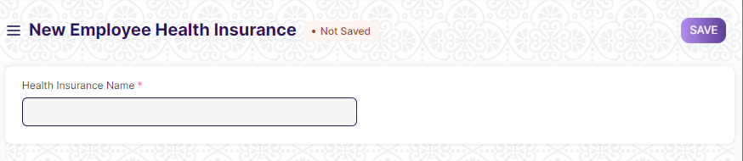

Figure 6 : Employee Health Insurance Screen

**Field List**

The following table describes the UI fields present in this screen :

|  |  |  |  |  |  |  |
| --- | --- | --- | --- | --- | --- | --- |
| **ID** | **Label** | **Type** | **Mandatory** | **Validation/ Action** | **Remarks** | **R = Rename**  **N= New**  **D= Delete** |
| 1 | Health Insurance Name | Text | Yes |  | Set the name of the Employee health Insurance |  |

**Users: Roles & Permission**

The following table describes the users and their roles and permissions for the screens :

|  |  |  |  |  |  |  |  |  |  |
| --- | --- | --- | --- | --- | --- | --- | --- | --- | --- |
| **ID** | **Role** | **Select** | **Read** | **Write** | **Create** | **Delete** | **Submit** | **Cancel** | **Amend** |
| 1 | HR Admin/Director Admin | Yes | Yes | Yes | Yes | Yes | NA | NA | NA |
| 2 | HR Manager/CS | No | Yes | Yes | Yes | No | NA | NA | NA |
| 3 | HR Assistant | No | Yes | No | No | No | NA | NA | NA |
| 4 | Employee | No | Yes | No | No | No | NA | NA | NA |

### Category

**General Description**

The Following table describe overall information about this screen:

|  |  |  |
| --- | --- | --- |
| **Description** | | 1.Category helps the users to define different types of employee like PWD,ex-serviceman and so on. |
| **Navigation** | Home > HRMS> Employee> Category | |
| **Pre-requisites** | NA | |
| **Existing Screen Name** | NA | |
| **New Screen Name** | Category | |

**Screenshot**

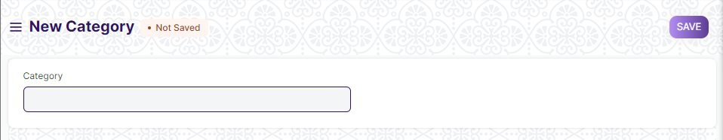

Figure 7 : Category Screen

**Field List**

The following table describes the UI fields present in this screen :

|  |  |  |  |  |  |  |
| --- | --- | --- | --- | --- | --- | --- |
| **ID** | **Label** | **Type** | **Mandatory** | **Validations/Action** | **Remarks** | R= Rename  N= New  D= Delete |
| 1 | Category | Text |  |  |  | N |

**Users: Roles & Permission**

The following table describes the users and their roles and permissions for the screens :

|  |  |  |  |  |  |  |  |  |  |
| --- | --- | --- | --- | --- | --- | --- | --- | --- | --- |
| **ID** | **Role** | **Select** | **Read** | **Write** | **Create** | **Delete** | **Submit** | **Cancel** | **Amend** |
| 1 | HR Admin/Director Admin | Yes | Yes | Yes | Yes | Yes | NA | NA | NA |
| 2 | HR Manager/CS | No | Yes | Yes | Yes | No | NA | NA | NA |
| 3 | HR Assistant | No | Yes | No | No | No | NA | NA | NA |
| 4 | Employee | No | No | No | No | No | NA | NA | NA |

### Employee

**General Description**

The Following table describe overall information about this screen:

|  |  |  |
| --- | --- | --- |
| **Description** | | 1. Employee is an individual who works part-time or full-time under a contract of employment, and has recognized rights and duties of your company. 2. User can manage the Employee master. It captures the demographic, personal and professional details, joining and leave details, etc. of the Employee. |
| **Navigation** | Home > HRMS> Employee> Employee | |
| **Pre-requisites** | The system should have records in the following screen:   1. Employment Type 2. Department 3. Employee Grade 4. Branch 5. Designation 6. Leave Policy 7. Holiday List 8. Shift Type 9. Employee Health Insurance 10. Job Applicant(Optional) | |
| **Existing Screen Name** | Employee | |
| **New Screen Name** | No change | |

**Screenshot**

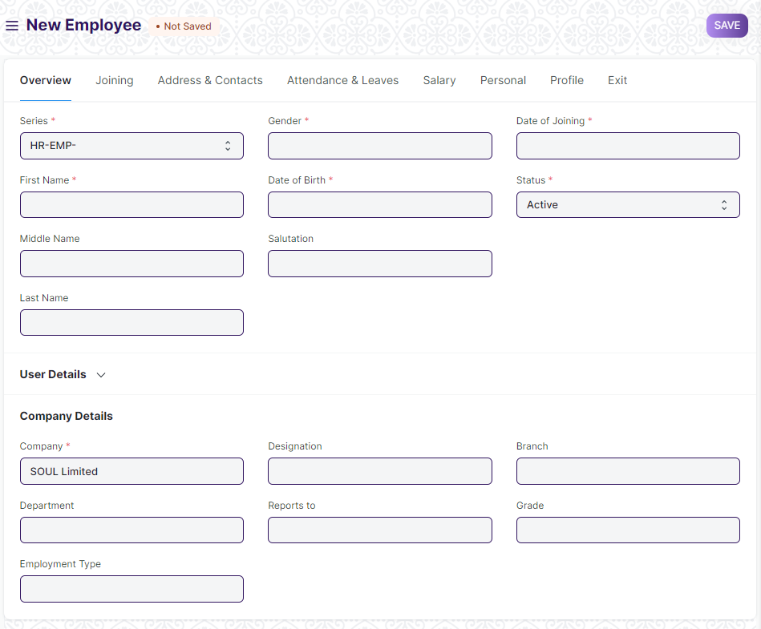

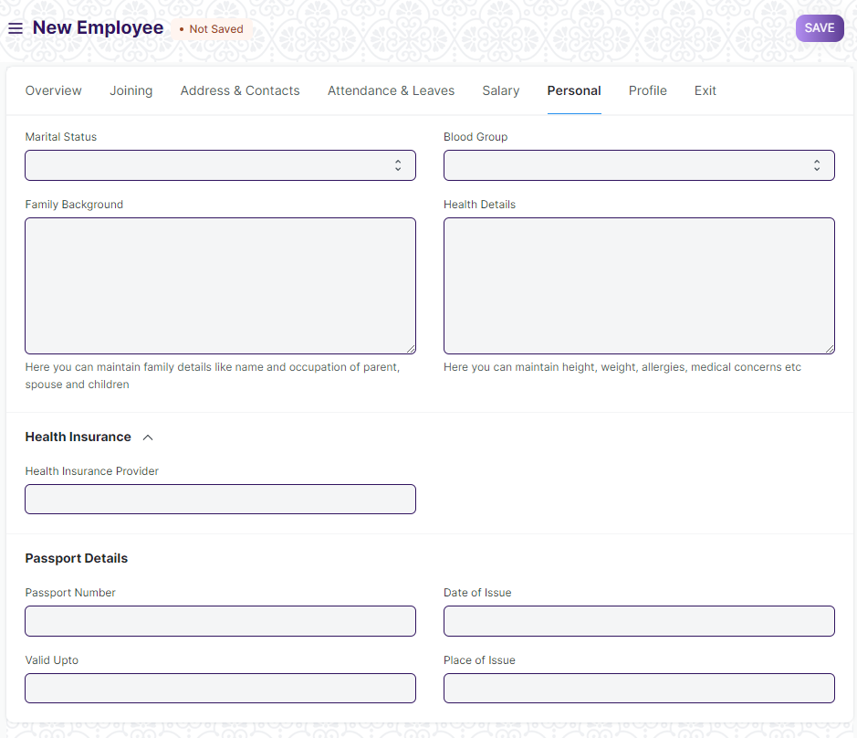

Figure 8 : Employee Screen

**Field List**

The following table describes the UI fields present in this screen :

|  |  |  |  |  |  |  |  |  |  |  |  |  |
| --- | --- | --- | --- | --- | --- | --- | --- | --- | --- | --- | --- | --- |
| **ID** | | **Label** | | **Type** | | **Mandatory** | | **Validations/Action** | | **Remarks** | | R=Rename  N= New  D= Delete |
| 1 | | Employee | | Text | |  | |  | |  | |  |
| 2 | | Series | | Dopdown | | Yes | |  | |  | |  |
| 3 | | First Name | | Text | | Yes | |  | |  | |  |
| 4 | | Middle Name | | Text | |  | |  | |  | |  |
| 5 | | Last Name | | Text | |  | |  | |  | |  |
| 6 | | Full Name | | Text | |  | |  | |  | |  |
| 7 | | Gender | | Link | | Yes | |  | |  | |  |
| 8 | | Date of Birth | | Date | | Yes | |  | |  | |  |
| 9 | | Category | | Link | |  | | Link to Master Screen “Category” | |  | | N |
| 10 | | Salutation | | Link | |  | | Link to Screen”Salutation” | |  | |  |
| 11 | | Date of Joining | | Date | |  | |  | |  | |  |
| 12 | | Image | | Attach Image | |  | |  | |  | |  |
| 13 | | Status | | Dopdown | | Yes | | **Options:**   1. Active 2. Inactive 3. Suspended 4. Left | |  | |  |
| 14 | | User ID | | Link | |  | | Link to the Screen”User” | |  | |  |
| 15 | | Create User | | Button | |  | |  | |  | |  |
| 16 | | Create User Permission | | Checkbox | |  | | If checked “User Permission”  restrictions will be created for the employee. | |  | |  |
| 17 | | Company | | Link | | Yes | | The field will be auto-populated as per the settings. | |  | |  |
| 18 | | Department | | Link | |  | | Link to the master screen Department. | |  | |  |
| 19 | | Employment Type | | Link | |  | | Link to the master screen Employment Type | |  | |  |
| 20 | | Employee Number | | Text | |  | |  | |  | |  |
| 21 | | Designation | | Link | |  | | Link to the master screen Designation. | |  | |  |
| 22 | | Reports to | | Link | |  | | Link to master screen Employee | |  | |  |
| 23 | | Branch | | Link | |  | | Link to master screen Branch | |  | |  |
| 24 | | Grade | | Link | |  | | Link to master screen Employee Grade. | |  | |  |
| Tab Break | | | | | | | | | | | | |
| 25 | | Job Applicant | | Link | |  | | Link to screen Job Applicant. | |  | |  |
| 26 | | Offer Date | | Date | |  | |  | |  | |  |
| 27 | | Confirmation Date | | Date | |  | |  | |  | |  |
| 28 | | Contract End Date | | Date | |  | |  | |  | |  |
| 29 | | Notice (days) | | Number | |  | |  | |  | |  |
| 30 | | Date Of Retirement | | Date | |  | |  | |  | |  |
| Tab Break | | | | | | | | | | | | |
| 31 | | Mobile | | Text | |  | |  | |  | |  |
| 32 | | Personal Email | | Text | |  | |  | |  | |  |
| 33 | | Company Email | | Text | |  | |  | |  | |  |
| 34 | | Preferred Contact Email | | Dopdown | |  | | **Options:**   1. Company Email 2. Personal Email   3.User ID | |  | |  |
| 35 | | Preferred Email | | Text | |  | |  | |  | |  |
| 36 | | Unsubscribed | | Checkbox | |  | |  | |  | |  |
| 37 | | Current Address | | Small Text | |  | |  | |  | |  |
| 38 | | Current Address Is | | Dopdown | |  | | Options:   1. Rented 2. Owned | |  | |  |
| 39 | | Permanent Address | | Small Text | |  | |  | |  | |  |
| 40 | | Permanent Address Is | | Dopdown | |  | | Options:   1. Rented 2. Owned | |  | |  |
| 41 | | Emergency Contact Name | | Text | |  | |  | |  | |  |
| 42 | | Emergency Phone | | Text | |  | |  | |  | |  |
| 43 | | Relation | | Text | |  | |  | |  | |  |
| Tab Break | | | | | | | | | | | | |
| 44 | | Attendance Device ID (Biometric/RF tag ID) | | Text | |  | |  | |  | |  |
| 45 | | Holiday List | | Link | |  | | Link to the master screen “Holiday List” | |  | |  |
| 46 | | Default Shift | | Link | |  | | Link to the master screen “Shift Type” | |  | |  |
| 47 | | Expense Approver | | Link | |  | | Link to the screen “User” | |  | |  |
| 48 | | Leave Approver | | Link | |  | | Link to the screen “User” | |  | |  |
| 49 | | Shift Request Approver | | Link | |  | | Link to the screen “User” | |  | |  |
| Tab Break | | | | | | | | | | | | |
| 50 | | Cost to Company (CTC) | | Currency | |  | |  | |  | |  |
| 51 | | Salary Currency | | Link | |  | |  | |  | |  |
| 52 | | Salary Mode | | Dopdown | |  | | Options:   1. Bank 2. Cash 3. Cheque | |  | |  |
| 53 | | Payroll Cost Center | | Link | |  | | Link to the screen “Cost Center” | |  | |  |
| 54 | | PAN Number | | Text | |  | |  | |  | |  |
| 55 | | Aadhar Number | | Text | |  | |  | |  | |  |
| 56 | | Provident Fund Account | | Text | |  | |  | |  | |  |
| 57 | | Bank Name | | Text | |  | |  | |  | |  |
| 58 | | Bank A/C No. | | Text | |  | |  | |  | |  |
| 59 | | IFSC Code | | Text | |  | |  | |  | |  |
| 60 | | MICR Code | | Text | |  | |  | |  | |  |
| 61 | | Marital Status | | Dopdown | |  | | Options:  1 Single  2 Married  3 Divorced  4 Widowed | |  | |  |
| 62 | | Family Background | | Small Text | |  | |  | |  | |  |
| 63 | | Family Background Details | | Table | |  | | This table is described below | |  | | N |
| 64 | | Health Insurance Details | | Table | |  | | This table is described below | |  | | N |
| 65 | | Blood Group | | Dopdown | |  | | Options:  A+  A-  B+  B-  AB+  AB-  O+  O- | |  | |  |
| 66 | | Health Details | | Small Text | |  | |  | |  | |  |
| 67 | | Health Insurance Provider | | Link | |  | | Link to screen Employee Insurance Provider | |  | |  |
| 68 | | Health Insurance No | | Text | |  | |  | |  | |  |
| 69 | | Passport Number | | Text | |  | |  | |  | |  |
| 70 | | Valid Upto | | Date | |  | |  | |  | |  |
| 71 | | Date of Issue | | Date | |  | |  | |  | |  |
| 72 | | Place of Issue | | Text | |  | |  | |  | |  |
| 73 | | Visa Details | | Table | |  | | This table is described below | |  | | N |
| 74 | | Bio / Cover Letter | | Text Editor | |  | |  | |  | |  |
| 75 | | Education Details | | Table | |  | | This table is described below | |  | |  |
| 76 | | External Work History | | Table | |  | | This table is described below | |  | |  |
| 77 | | Internal Work History | | Table | |  | | This table is described below | |  | |  |
| 78 | | Additional Charges | | Table | |  | | This table is described below | |  | | N |
| 79 | | Criminal Cases(If any) | | Table | |  | | This table is described below | |  | |  |
| 80 | | Resignation Letter Date | | Date | |  | |  | |  | |  |
| 81 | | Relieving Date | | Date | |  | |  | |  | |  |
| 82 | | Exit Interview Held On | | Date | |  | |  | |  | |  |
| 83 | | New Workplace | | Text | |  | |  | |  | |  |
| 84 | | Leave Encashed? | | Dopdown | |  | |  | |  | |  |
| 85 | | Encashment Date | | Date | |  | |  | |  | |  |
| 86 | | Reason for Leaving | | Small Text | |  | |  | |  | |  |
| 87 | | Feedback | | Small Text | |  | |  | |  | |  |
| 88 | | Old Parent | | Text | |  | |  | |  | |  |
| **Family Background Details** | | | | | | | | | | | | | |
| **ID** | | **Label** | | **Type** | | **Mandatory** | | **Validation/ Action** | | **Remarks** | | **R = Rename**  **N= New**  **D= Delete** | |
| 1 | | Name | | Text | | Yes | |  | |  | | N | |
| 2 | | Relation | | Text | | Yes | |  | |  | | N | |
| 3 | | Occupation | | Text | | Yes | |  | |  | | N | |
| 4 | | Gender | | Link | | Yes | | Link to the screen Gender | |  | |  | |
| 5 | | Contact | | Number | | Yes | |  | |  | | N | |
| 6 | | Date of Birth | | Date | | Yes | |  | |  | | N | |
| 7 | | Annual Income | | Number | |  | |  | |  | | N | |
| Health Details | | | | | | | | | | | | | |
| **ID** | | **Label** | | **Type** | | **Mandatory** | | **Validation/ Action** | | **Remarks** | | **R = Rename**  **N= New**  **D= Delete** | |
| 1 | | Disease name | | Text | | Yes | |  | |  | | N | |
| 2 | | Description | | Text Editor | | Yes | |  | |  | | N | |
| 3 | | Recommendation by Physician | | Text | |  | |  | |  | | N | |
| 4 | | Attach | |  | |  | |  | |  | | N | |
| **Visa Details** | | | | | | | | | | | | | |
| **ID** | | **Label** | | **Type** | | **Mandatory** | | **Validation/ Action** | | **Remarks** | | **R = Rename**  **N= New**  **D= Delete** | |
| 1 | | Visa Number | | Text | | Yes | |  | |  | | N | |
| 2 | | Visa Type | | Dropdown | | Yes | | **Options:**   1. Tourist Visa(T) 2. Business Visa(B) 3. Employment Visa(E) 4. Medical Visa(Med) 5. Conference(C) 6. Entry Visa(X) | |  | | N | |
| 3 | | Visa Sub Type | | Dropdown | |  | | **Options:**   1. T-1 2. T-2 3. T-3 4. B-1 5. B-2 6. B-3 7. B-4 8. B-5 9. B-6 10. B-7 11. B-Sports 12. B-1X 13. B-2X 14. B-3X 15. B-4X 16. E-1 17. E-2 18. E-3 19. E-4 20. E-5 21. E-1X 22. E-2X 23. E-3X 24. E-4X 25. E-5X 26. F 27. C-1 28. C-2 29. X-1 30. X-2 31. X-Misc | | |  |  | |
| 4 | | Date of issue | | Date | | Yes | | Link to the screen Gender | | |  | N | |
| 5 | | Date of Expiry | | Date | | Yes | |  | | |  | N | |
| 6 | | Service Number | | Text | |  | |  | | |  | N | |
| 7 | | Number of entries | | Number | |  | |  | | |  | N | |
| **Education Qualification Details** | | | | | | | | | | | | | |
| **ID** | | **Label** | | **Type** | | **Mandatory** | | **Validation/ Action** | | | **Remarks** | **R = Rename**  **N= New**  **D= Delete** | |
| 1 | | School/University | | Small Text | | Yes | |  | | |  |  | |
| 2 | | Qualification | | Text | | Yes | |  | | |  |  | |
| 3 | | Level | | Dopdown | | Yes | | **Options:**   1. Graduate 2. Post Graduate 3. Under Graduate | | |  |  | |
| 4 | | Year of Passing | | Number | | Yes | |  | | |  |  | |
| 5 | | Class / Percentage | | Number | | Yes | |  | | |  |  | |
| 6 | | Major/Optional Subjects | | Text | | Yes | |  | | |  |  | |
| **External Work History** | | | | | | | | | | | | | |
| **ID** | | **Label** | | **Type** | | **Mandatory** | | **Validation/ Action** | | | **Remarks** | **R = Rename**  **N= New**  **D= Delete** | |
| 1 | | Company | | Text | | Yes | | Company will be auto-populated on the basis of setting. | | |  |  | |
| 2 | | Designation | | Text | | Yes | |  | | |  |  | |
| 3 | | Salary | | Currency | | Yes | |  | | |  |  | |
| 4 | | Address | | Small Text | | Yes | |  | | |  |  | |
| 5 | | Contact | | Text | | Yes | |  | | |  |  | |
| 6 | | Total Experience | | Text | | Yes | |  | | |  |  | |
| **Internal Work History** | | | | | | | | | | | | | |
| **ID** | | **Label** | | **Type** | | **Mandatory** | | **Validation/ Action** | | | **Remarks** | **R = Rename**  **N= New**  **D= Delete** | |
| 1 | | Branch | | Link | |  | | Link to master screen Branch | | |  |  | |
| 2 | | Department | | Link | |  | | Link to master screen Department | | |  |  | |
| 3 | | Designation | | Link | |  | | Link to master screen Designation | | |  |  | |
| 4 | | From Date | | Date | |  | |  | | |  |  | |
| 5 | | To Date | | Date | |  | |  | | |  |  | |
| 6 | | Employee Re-engagement ID | | Link | |  | |  | | |  | N | |
| **Additional Charges** | | | | | | | | | | | | | |
| **ID** | | **Label** | | **Type** | | **Mandatory** | | **Validation/ Action** | | | **Remarks** | **R = Rename**  **N= New**  **D= Delete** | |
| 1 | | Project Name | | Text | |  | |  | | |  | N | |
| 2 | | Place of Work | | Text | |  | |  | | |  | N | |
| 3 | | Description of Work | | Text | |  | |  | | |  | N | |
| 4 | | Role | | Link | |  | |  | | |  | N | |
| 5 | | Assigned By | | Link | |  | |  | | |  | N | |
| 6 | | Start Date | | Date | |  | |  | | |  | N | |
| 7 | | End Date | | Date | |  | |  | | |  | N | |
| 8 | | Office Order | | Attach | |  | |  | | |  | N | |
| **Criminal Cases(if any)** | | | | | | | | | | | | | |
| **ID** | | **Label** | | **Type** | | **Mandatory** | | **Validation/ Action** | | | **Remarks** | **R = Rename**  **N= New**  **D= Delete** | |
| 1 | | Description | | Text | |  | |  | | |  | N | |
| 2 | | Status | | Dropdown | |  | | Options:  Resolved  Pending  Ongoing | | |  | N | |

**Users: Roles & Permission**

The following table describes the users and their roles and permissions for the screens :

|  |  |  |  |  |  |  |  |  |  |
| --- | --- | --- | --- | --- | --- | --- | --- | --- | --- |
| **ID** | **Role** | **Select** | **Read** | **Write** | **Create** | **Delete** | **Submit** | **Cancel** | **Amend** |
| 1 | HR Admin/Director Admin | Yes | Yes | Yes | Yes | Yes | NA | NA | NA |
| 2 | HR Manager/CS | No | Yes | Yes | Yes | No | NA | NA | NA |
| 3 | HR Assistant | No | Yes | No | No | No | NA | NA | NA |
| 4 | Employee | No | Yes | No | No | No | NA | NA | NA |

### Employee Group

**General Description**

The Following table describe overall information about this screen:

|  |  |  |
| --- | --- | --- |
| **Description** | | 1. Employee Group is grouping of Employees based on some attributes such as Designation, Grade, Branch, etc. |
| **Navigation** | Home > HRMS> Employee> Employee Group | |
| **Pre-requisites** | The system should have records in the following screen:   1. Employee | |
| **Existing Screen Name** | Employee Group | |
| **New Screen Name** | No change | |

**Screenshot**

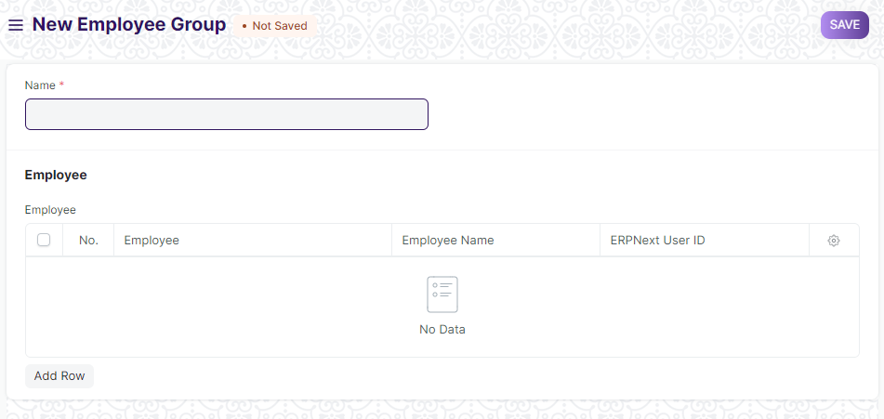

Figure 9 : Employee Group Screen

**Field List**

The following table describes the UI fields present in this screen :

|  |  |  |  |  |  |  |
| --- | --- | --- | --- | --- | --- | --- |
| **ID** | **Label** | **Type** | **Mandatory** | **Validations/Action** | **Remarks** | R=Rename  N= New  D= Delete |
| 1 | Name | Text | Yes |  |  |  |
| 2 | Employee | Table |  | This screen is described below |  |  |
| **Employee** | | | | | | |
| **ID** | **Label** | **Type** | **Mandatory** | **Validation/ Action** | **Remarks** | R=Rename  N= New  D= Delete |
| 1 | Employee | Small Text | Yes |  |  |  |
| 2 | Employee Name | Text | Yes | Employee name will be auto-populated on the basis of Employee Id. |  |  |
| 3 | ERPNeext User ID | Link |  | Link to the Screen Users |  |  |

**Users: Roles & Permission**

The following table describes the users and their roles and permissions for the screens :

|  |  |  |  |  |  |  |  |  |  |
| --- | --- | --- | --- | --- | --- | --- | --- | --- | --- |
| **ID** | **Role** | **Select** | **Read** | **Write** | **Create** | **Delete** | **Submit** | **Cancel** | **Amend** |
| 1 | HR Admin/Director Admin | Yes | Yes | Yes | Yes | Yes | NA | NA | NA |
| 2 | HR Manager/CS | No | Yes | Yes | Yes | No | NA | NA | NA |
| 3 | HR Assistant | No | Yes | No | No | No | NA | NA | NA |
| 4 | Employee | No | Yes | No | No | No | NA | NA | NA |

### HR Settings

**General Description**

The Following table describe overall information about this screen:

|  |  |  |
| --- | --- | --- |
| **Description** | | 1. HR Settings allow global settings for HR-related documents. |
| **Navigation** | Home > HRMS> Settings > HR Settings | |
| **Pre-requisites** | NA | |
| **Existing Screen Name** | HR Settings | |
| **New Screen Name** | No change | |

**Screenshot**

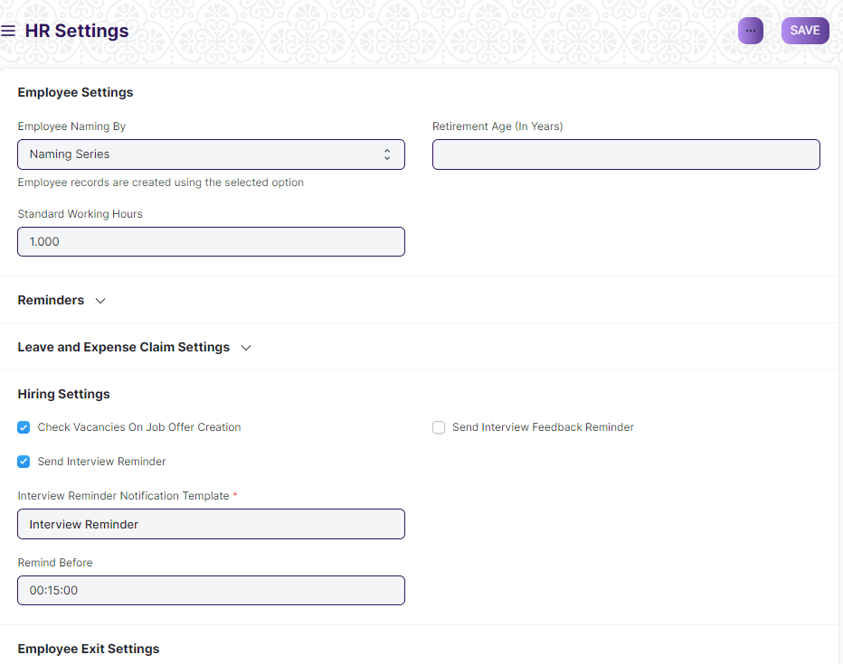

Figure 10 : HR Settings Screen

**Field List**

The following table describes the UI fields present in this screen :

|  |  |  |  |  |  |  |
| --- | --- | --- | --- | --- | --- | --- |
| **ID** | **Label** | **Type** | **Mandatory** | **Validation/ Action** | **Remarks** | **R = Rename**  **N= New**  **D= Delete** |
| 1 | Employee Naming By | Dropdown | Yes |  |  |  |
| 2 | Standard Working Hours | Float |  |  |  |  |
| 3 | Retirement Age (In Years) | Text |  |  |  |  |
| 4 | Reminders | Checkbox |  |  |  |  |
| 5 | Birthdays | Dropdown |  |  |  |  |
| 6 | Work Anniversaries | Dropdown |  |  |  |  |
| 7 | Holidays | Dropdown |  |  |  |  |
| 8 | Set the frequency for holiday reminders | Dropdown |  |  |  |  |
| 9 | Send Leave Notification | Checkbox |  |  |  |  |
| 10 | Leave Approval Notification Template | Link |  |  |  |  |
| 11 | Leave Status Notification Template | Link |  |  |  |  |
| 12 | Leave Approver Mandatory in Leave Application | Checkbox |  |  |  |  |
| 13 | Restrict Backdated Leave Application | Checkbox |  |  |  |  |
| 14 | Role Allowed to Create Backdated Leave Application | Link |  |  |  |  |
| 15 | Expense Approver Mandatory In Expense Claim | Checkbox |  |  |  |  |
| 16 | Show Leaves Of All Department Members In Calendar | Checkbox |  |  |  |  |
| 17 | Auto Leave Encashment | Checkbox |  |  |  |  |
| 18 | Check Vacancies On Job Offer Creation | Checkbox |  |  |  |  |
| 19 | Send Interview Reminder | Checkbox |  |  |  |  |
| 20 | Interview Reminder Notification Template | Link |  |  |  |  |
| 21 | Remind Before | Time |  |  |  |  |
| 22 | Send Interview Feedback Reminder | Checkbox |  |  |  |  |
| 23 | Feedback Reminder Notification Template | Link |  |  |  |  |
| 24 | Exit Questionnaire Web Form | Link |  |  |  |  |
| 25 | Exit Questionnaire Notification Template | Link |  |  |  |  |

**Users: Roles & Permission**

The following table describes the users and their roles and permissions for the screens :

|  |  |  |  |  |  |  |  |  |  |
| --- | --- | --- | --- | --- | --- | --- | --- | --- | --- |
| **ID** | **Role** | **Select** | **Read** | **Write** | **Create** | **Delete** | **Submit** | **Cancel** | **Amend** |
| 1 | HR Admin/Director Admin | Yes | Yes | Yes | Yes | Yes | No | No | No |
| 2 | HR Manager | No | Yes | Yes | Yes | No | No | No | No |
| 3 | HR Assistant | No | Yes | No | No | No | No | No | No |
| 4 | Employee | No | No | No | No | No | No | No | No |

## Recruitment

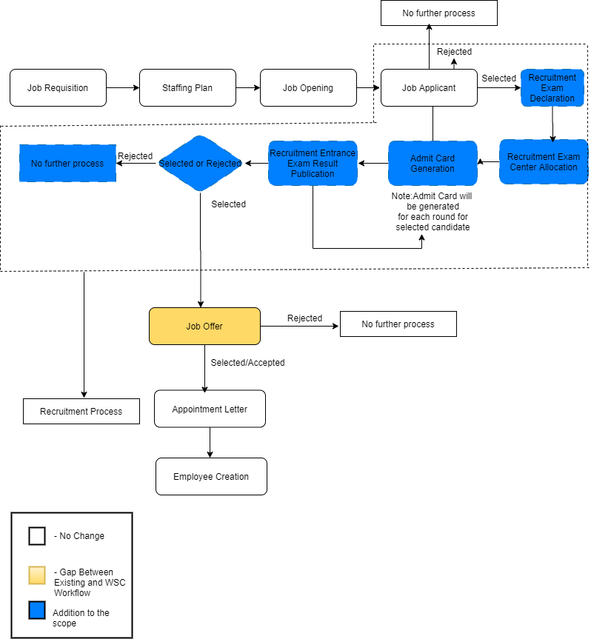

Figure 11 : Recruitment Workflow

**Description:**

**Job Requisition**

Job Requisition helps an Employee to raise request for hiring for particular designation and department.

**Staffing Plan**

Staffing Plan helps you to plan manpower requirements for your Company.

**Job Opening**

A Job Opening is a job vacancy in your Company. You can make a record of the open vacancies in your company using Job Opening.

**Job Applicant**

Job Applicant maintain a list of people who have applied against a particular [Job Opening](https://frappehr.com/docs/v14/user/manual/en/human-resources/job-opening).

**Recruitment Exam Declaration**

Recruitment Exam Declaration helps to you to declare exam for recruitment process.

**Recruitment Exam Center Allocation**

Recruitment Exam Center Allocation helps user to allocate exam center for different exam.

**Admit Card Generation**

Admit card will be generated at each step of selection process for selected candidates.

**Recruitment Entrance Exam Result Publication**

It helps to publish result for different exam declaration and on the basis of this again admit card will be generated.

**Job Offer**

Job Offer is given to selected candidates after interview and selection which states the offered salary package, designation, grade, department, number of days entitled for leave among other information.

**Appointment Letter**

Appointment Letter will be generated for the candidate who has accepted the Job Offer

**Employee**

Once the Job Offer is accepted and Appointment letter is given,Employee can be created.

**Masters**

### Center Selection Master

**General Description**

The following table describe overall information about this screen:

|  |  |
| --- | --- |
| **Description** | 1. A master screen where basic information regarding a exam centre is stored |
| **Navigation** | Home > Admission > Center Selection Master |
| **Pre-requisites** | The system should have records in the following screen   1. State 2. District |
| **Existing Screen Name** | NA |
| **New Screen Name** | Center Selection Masters |

**Screenshot**

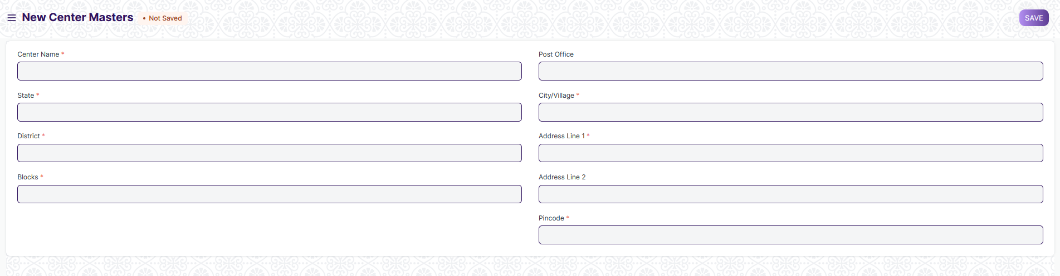

Figure 12: Center Selection Master Screen

**Field List:**

The following table describes the UI fields present in this screen :

|  |  |  |  |  |  |  |
| --- | --- | --- | --- | --- | --- | --- |
| **ID** | **Label** | **Type** | **Mandatory** | **Validation / Action** | **Remarks** | **R= Rename**  **N= New**  **D= Delete** |
| 1 | Enable | Checkbox |  |  |  |  |
| 2 | Center Name | Text | Yes |  |  |  |
| 3 | States | Link | Yes | Links to States Master Screen |  |  |
| 4 | Districts | Link | Yes | Links to Districts Master Screen and filtered with respect to State |  |  |
| 5 | Blocks | Link | Yes | Links to Blocks Master Screen and filtered with respect to District |  |  |
| 6 | Post Office | Text |  |  |  |  |
| 7 | City/Village | Text | Yes |  |  |  |
| 8 | Address | Text |  |  |  |  |
| 10 | Pincode | Number | Yes |  |  |  |
| 11 | Total Seating Capacity | Number | Yes |  |  |  |

**Users: Roles & Permission**

The following table describes the users and their roles and permissions for the screens :

|  |  |  |  |  |  |  |  |  |  |
| --- | --- | --- | --- | --- | --- | --- | --- | --- | --- |
| **ID** | **Role** | **Select** | **Read** | **Write** | **Create** | **Delete** | **Submit** | **Cancel** | **Amend** |
| 1 | HR Admin/Director Admin | Yes | Yes | Yes | Yes | Yes | NA | NA | NA |
| 2 | HR Manager/CS | No | Yes | Yes | Yes | No | NA | NA | NA |
| 3 | HR Assistant | No | Yes | No | No | No | NA | NA | NA |
| 4 | Employee | No | No | No | No | No | NA | NA | NA |

### Interview Type

**General Description**

The Following table describe overall information about this screen:

|  |  |  |
| --- | --- | --- |
| **Description** | | 1. Interview Type form helps you to define different kinds of interview like HR Interview,Technical Interview and so on. |
| **Navigation** | Home > HRMS> Recruitment > Interview Type | |
| **Pre-requisites** | The system should have records in the following screen:   1. Company | |
| **Existing Screen Name** | Interview Type | |
| **New Screen Name** | No change | |

**Screenshot**

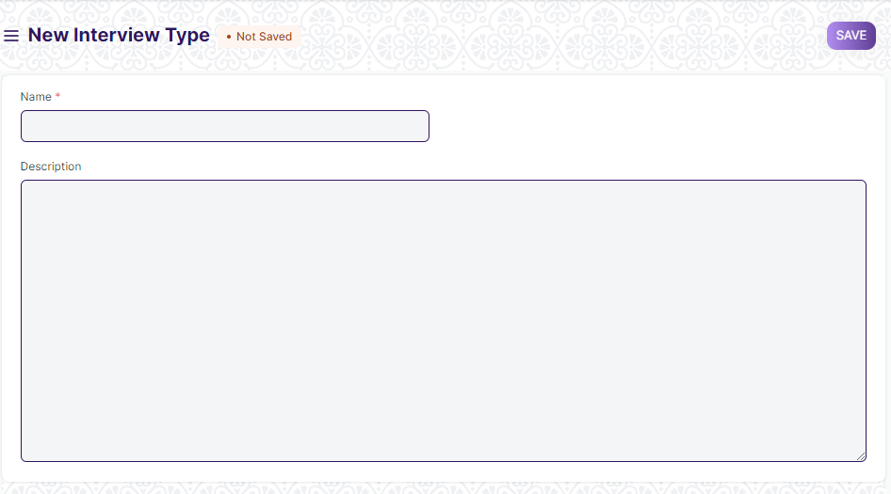

Figure 13 : Interview Type Screen

**Field List:**

The following table describes the UI fields present in this screen :

|  |  |  |  |  |  |  |
| --- | --- | --- | --- | --- | --- | --- |
| **ID** | **Label** | **Type** | **Mandatory** | **Validation/ Action** | **Remarks** | **R = Rename**  **N= New**  **D= Delete** |
| 1 | Name | Text | Yes |  |  |  |
| 2 | Description | Link Field |  |  |  |  |

**Users: Roles & Permission**

The following table describes the users and their roles and permissions for the screens :

|  |  |  |  |  |  |  |  |  |  |
| --- | --- | --- | --- | --- | --- | --- | --- | --- | --- |
| **ID** | **Role** | **Select** | **Read** | **Write** | **Create** | **Delete** | **Submit** | **Cancel** | **Amend** |
| 1 | HR Admin/Director Admin | Yes | Yes | Yes | Yes | Yes | NA | NA | NA |
| 2 | HR Manager | No | Yes | Yes | Yes | No | NA | NA | NA |
| 3 | HR Assistant | No | Yes | No | No | No | NA | NA | NA |
| 4 | Employee | No | No | No | No | No | NA | NA | NA |

### Interview Round

**General Description**

The following table describes overall information about this screen:

|  |  |
| --- | --- |
| **Description** | 1. Interview round will consist of different interview round along with other interview details like skills and expected ratings and so on. |
| **Navigation** | Home > HRMS > Recruitment > interview round |
| **Pre-requisites** | The system should have records in the following screen:   1. Interview type |
| **Existing Screen Name** | Interview Type |
| **New Screen Name** | No change |

**Screenshot**

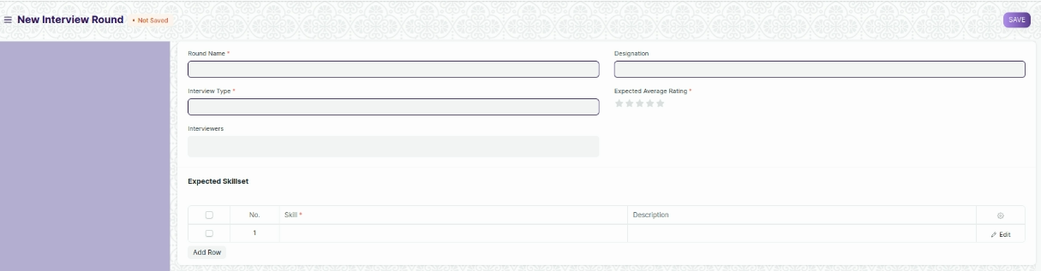

Figure 14 : Interview Round screen

**Field List**

The following table describes the UI fields present in this screen :

|  |  |  |  |  |  |  |
| --- | --- | --- | --- | --- | --- | --- |
| **ID** | **Label** | **Type** | **Mandatory** | **Validation / Action** | **Remarks** | **R= Rename**  **N= New**  **D= Delete** |
| 1 | Round Name | Text | Yes |  |  |  |
| 2 | Interview Type | Link | Yes | Link Field to Interview Type Master screen |  |  |
| 3 | Interviewers | Select |  | Options :  All the data of Interviewer screen. |  |  |
| 4 | Designation | Link |  | Link Field to Designation master screen. |  |  |
| 5 | Expected Average Rating | Rating | Yes |  |  |  |
| 6 | Expected Skillset | table | Yes | This table is described below |  |  |

|  |  |  |  |  |  |  |
| --- | --- | --- | --- | --- | --- | --- |
| **Expected skill set** | | | | | | |
| **ID** | **Label** | **Type** | **Mandatory** | **Validation / Action** | **Remarks** | **R= Rename**  **N= New**  **D= Delete** |
| 1 | Skill | Link Field | Yes | Link Field to master screen skill |  |  |
| 2 | Description | Text Field |  |  |  |  |

**Users: Roles & Permission**

The following table describes the users and their roles and permissions for the screens :

|  |  |  |  |  |  |  |  |  |  |
| --- | --- | --- | --- | --- | --- | --- | --- | --- | --- |
| **ID** | **Role** | **Select** | **Read** | **Write** | **Create** | **Delete** | **Submit** | **Cancel** | **Amend** |
| 1 | HR Admin/Director Admin | Yes | Yes | Yes | Yes | Yes | NA | NA | NA |
| 2 | HR Manager/CS | No | Yes | Yes | Yes | Yes | NA | NA | NA |
| 3 | HR Assistant | No | Yes | No | No | No | NA | NA | NA |
| 4 | Employee | No | Yes | No | No | No | NA | NA | NA |

**Transactional Screens**

### Job Requisition

**General Description**

The following table describes overall information about this screen:

|  |  |
| --- | --- |
| **Description** | 1. A job requisition is a formal request recruiters or hiring managers fill out for their company's HR department to create a new position or to fill a job vacancy. |
| **Navigation** | Home > HRMS > Recruitment > Job Requisition |
| **Pre-requisites** | The system should have records in the following screen:   1. Department 2. Designation |
| **Existing Screen Name** | Job Requisition |
| **New Screen Name** | No change |

**Screenshot**

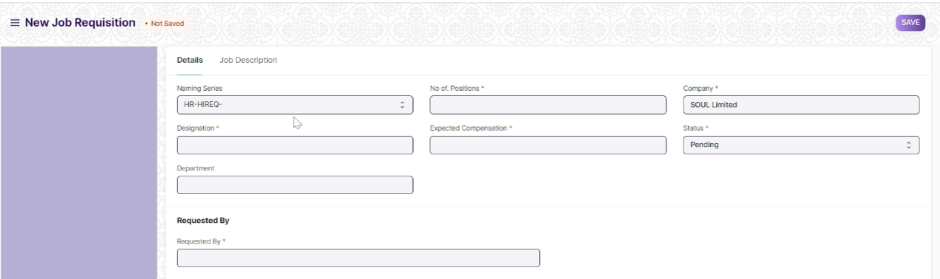



Figure 15 : Job Requisition Screen

**Field List:**

The following table describes the UI fields present in this screen :

|  |  |  |  |  |  |  |  |
| --- | --- | --- | --- | --- | --- | --- | --- |
| **ID** | **Label** | **Type** | **Mandatory** | **Validation / Action** | | **Remarks** | **R = Rename**  **N= New**  **D= Delete** |
| 1 | Designation | Link | Yes | Link to the master screen Designation | |  |  |
| 2 | Department | Link |  | Link to the master screen Department | |  |  |
| 3 | Employment Type | Link | Yes | Link Field to master screen Employment Type | |  | N |
| 4 | No of. Positions | Number | Yes |  | |  |  |
| 5 | Expected Compensation | Currency | Yes |  | |  |  |
| 6 | Company | Link | Yes | Link Field to master screen company. | |  |  |
| 7 | Status | Drop down | Yes | Options :  Pending  Open & Approved  Rejected  Filled  On Hold  Canceled | |  |  |
| 8 | Requested By | Link | Yes | Link Field to master Screen Employee | |  |  |
| 9 | Requested By (Name) | Data | Text Field |  | | Auto Fetched on selection of Employee |  |
| 10 | Department | Link |  |  | | Auto Fetched on selection of employee |  |
| 11 | Designation | Link |  |  | | Auto fetched on selection of employee |  |
| 12 | Posting Date | Date | Yes |  | |  |  |
| 13 | Completed On | Date |  |  | |  |  |
| 14 | Expected By | Date |  |  | |  |  |
| 15 | Time to Fill | Duration |  |  | |  |  |
| 16 | Job Description | Text |  |  | |  |  |
| 17 | Reason for Requesting | Text |  |  | |  |  |
| 18 | TOR (Term of Reference) | Attachment |  |  | |  | N |
| 19 | Financial Approval | Attachment |  |  | |  | N |
|  | | | | | | | |
| **Action Button** | | | | | **Description** | | |
| Approve | | | | | On clicking the button, the status in the form will be changed to Open&Approved. | | |
| Reject | | | | | On Clicking the button , the status in the form will be changed to Rejected | | |
| Cancel | | | | | On clicking the button , the status in the form will be changed to cancel. | | |

**Users: Roles & Permission**

The following table describes the users and their roles and permissions for the screens :

|  |  |  |  |  |  |  |  |  |  |
| --- | --- | --- | --- | --- | --- | --- | --- | --- | --- |
| **ID** | **Role** | **Select** | **Read** | **Write** | **Create** | **Delete** | **Submit** | **Cancel** | **Amend** |
| 1 | HR Admin/Director Admin | Yes | Yes | Yes | Yes | Yes | Yes | Yes | Yes |
| 2 | HR Manager/CS | No | Yes | Yes | Yes | No | Yes | Yes | No |
| 3 | HR Assistant | No | Yes | Yes | Yes | No | Yes | No | No |
| 4 | Employee | No | Yes | Yes | Yes | No | Yes | No | No |

### Staffing Plan

**General Description**

The following table describes overall information about this screen:

|  |  |
| --- | --- |
| **Description** | 1. Staffing Plan helps you to plan manpower requirements for your Company. |
| **Navigation** | Home > HRMS > Recruitment> Staffing Plan |
| **Pre-requisites** | The system should have records in the following screen:   1. Department 2. Designation |
| **Existing Screen Name** | Staffing Plan |
| **New Screen Name** | No change |

**Screenshot**

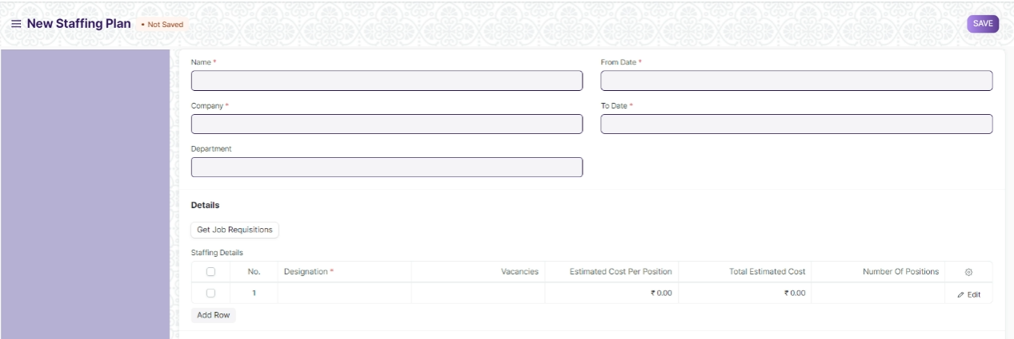



Figure 16 : Staffing Plan

**Field List**

The following table describes the UI fields present in this screen :

|  |  |  |  |  |  |  |
| --- | --- | --- | --- | --- | --- | --- |
| **ID** | **Label** | **Type** | **Mandatory** | **Validation / Action** | **Remark** | **R = Rename**  **N= New**  **D= Delete** |
| 1 | Company | Link | Yes | Link Field to the master screen Company. |  |  |
| 2 | Department | Link |  | Link Field to master screen Department |  |  |
| 3 | From Date | Date | Yes |  |  |  |
| 4 | To Date | Date | Yes |  |  |  |
| 5 | Employment Type | Link | Yes | Link Field to master screen Employment Type |  | N |
| 6 | Staffing Plan Detail | Table | Yes | This table is described below |  |  |
| 7 | Total Estimated Budget | Currency |  |  |  |  |

|  |  |  |  |  |  |  |  |
| --- | --- | --- | --- | --- | --- | --- | --- |
| **Staffing Plan Details** | | | | | | | |
| **ID** | **Label** | **Type** | **Mandatory** | **Validation / Action** | **Remark** | **R =Rename**  **N= New**  **D= Delete** |
| 1 | Designation | Link | Yes | Link Field to master screen Designation |  |  |
| 2 | Vacancies | Number |  |  |  |  |
| 3 | Estimated Cost Per Person | Currency |  |  |  |  |
| 4 | Total Estimated Cost |  |  |  |  |  |
| 5 | Current Count | Number |  |  |  |  |
| 6 | Current Opening | Number |  |  |  |  |
| 7 | Number of Positions | Number |  | Current count + current opening |  |  |

**Users: Roles & Permission**

The following table describes the users and their roles and permissions for the screens :

|  |  |  |  |  |  |  |  |  |  |
| --- | --- | --- | --- | --- | --- | --- | --- | --- | --- |
| **ID** | **Role** | **Select** | **Read** | **Write** | **Create** | **Delete** | **Submit** | **Cancel** | **Amend** |
| 1 | HR Admin/Director Admin | Yes | Yes | Yes | Yes | Yes | NA | NA | NA |
| 2 | HR Manager/CS | No | Yes | No | Yes | No | NA | NA | NA |
| 3 | HR Assistant | No | Yes | No | No | No | NA | NA | NA |
| 4 | Employee | No | Yes | No | No | No | NA | NA | NA |

### Job Opening

**General Description**

The following table describes overall information about this screen:

|  |  |
| --- | --- |
| **Description** | 1. A Job Opening is a job vacancy in your Company. You can make a record of the open vacancies in your company using Job Opening. |
| **Navigation** | Home > HRMS > Recruitment > Job Opening |
| **Pre-requisites** | The system should have records in the following screen:   1. Staffing Plan 2. Department |
| **Existing Screen Name** | Job Opening |
| **New Screen Name** | No Change |

**Screenshot**

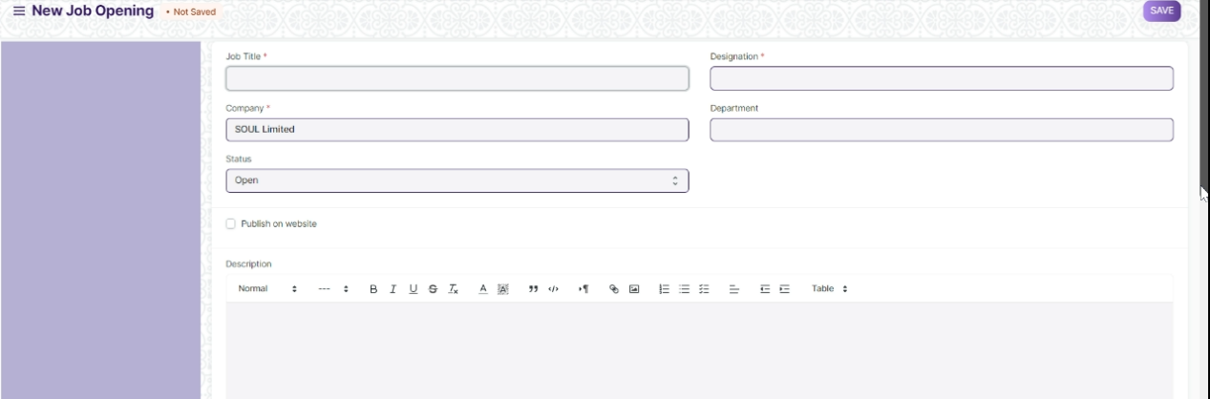

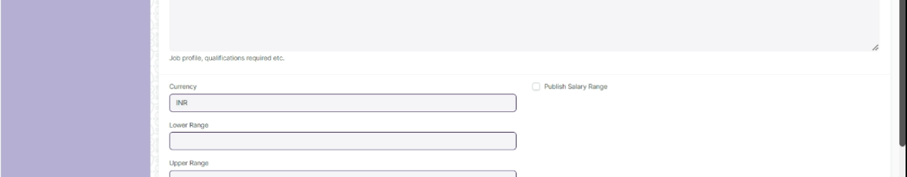

Figure 17 : Job Opening

**Field List**

The following table describes the UI fields present in this screen :

|  |  |  |  |  |  |  |
| --- | --- | --- | --- | --- | --- | --- |
| **ID** | **Label** | **Type** | **Mandatory** | **Validation / Action** | **Remarks** | **R = Rename**  **N= New**  **D= Delete** |
| 1 | Job Title | Text | Yes |  |  |  |
| 2 | Company | Link | Yes | Link Field to the master screen Company |  |  |
| 3 | Status | Drop down |  | Options :  Open  Closed |  |  |
| 4 | Designation | Link | Yes | Link Field to master screen Designation. |  |  |
| 5 | Employment Type | Link | Yes | Link Field to master screen Employment Type |  | N |
| 6 | Department | Link |  | Link Field to master screen Department |  |  |
| 7 | Staffing Plan | Link |  | Link Field to master screen Staffing Plan. Filtered based on selected Designation |  |  |
| 8 | Planned number of Positions | Number |  | Auto Fetched on selection of Staffing Plan |  |  |
| 9 | Job Requisition | Link |  | Auto Fetched on selection of Staffing plan. If Job requisition exists. |  |  |
| 10 | Vacancies | Number |  | Auto Fetched from Job Requisition |  |  |
| 11 | Number of selection Rounds | Number |  |  |  | N |
| 12 | Selection Rounds | Child table |  | This table is described below |  | N |
| 13 | Publish on website | Check box |  | If checked then the job opening will be published on the website. |  |  |
| 14 | Route | Text |  |  |  |  |
| 15 | Job Application Route | Text |  |  |  |  |
| 16 | Description | Text |  |  |  |  |
| 17 | Currency | Link |  | Link Field to the master screen Currency |  |  |
| 18 | Lower Range | Currency |  |  |  |  |
| 19 | Upper Range | Currency |  |  |  |  |
| 20 | Publish Salary Range | Checkbox |  | If checked then salary will be published on sit. |  |  |

|  |  |  |  |  |  |  |  |
| --- | --- | --- | --- | --- | --- | --- | --- |
| **Selection Rounds** | | | | | | | |
| **ID** | **Label** | **Type** | **Mandatory** | **Validation / Action** | **Remark** | **R=Rename**  **N= New**  **D= Delete** |
| 1 | Round Name | Text | Yes |  |  |  |

**Users: Roles & Permission**

The following table describes the users and their roles and permissions for the screens :

|  |  |  |  |  |  |  |  |  |  |
| --- | --- | --- | --- | --- | --- | --- | --- | --- | --- |
| **ID** | **Role** | **Select** | **Read** | **Write** | **Create** | **Delete** | **Submit** | **Cancel** | **Amend** |
| 1 | HR Admin/Director Admin | Yes | Yes | Yes | Yes | Yes | NA | NA | NA |
| 2 | HR Manager/CS | No | Yes | Yes | Yes | No | NA | NA | NA |
| 3 | HR Assistant | No | Yes | No | No | No | NA | NA | NA |
| 4 | Employee | No | Yes | No | No | No | NA | NA | NA |

### Job Applicant

**General Description**

The following table describes overall information about this screen:

|  |  |
| --- | --- |
| **Description** | 1. A Job Applicant Screen is the screen in which a person can able to apply for a job in your Company against a particular Job Opening. |
| **Navigation** | Home > HRMS > Recruitment > Job Applicant |
| **Pre-requisites** | The system should have records in the following screen:   1. Staffing Plan 2. Department 3. Job Opening |
| **Existing Screen Name** | Job Applicant |
| **New Screen name** | No change |

**Screenshot**

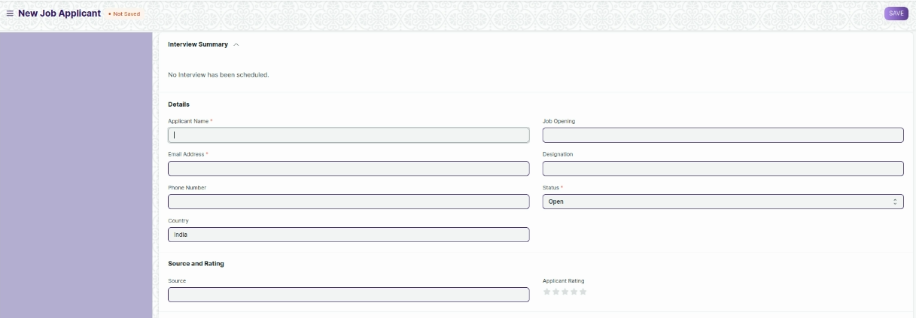

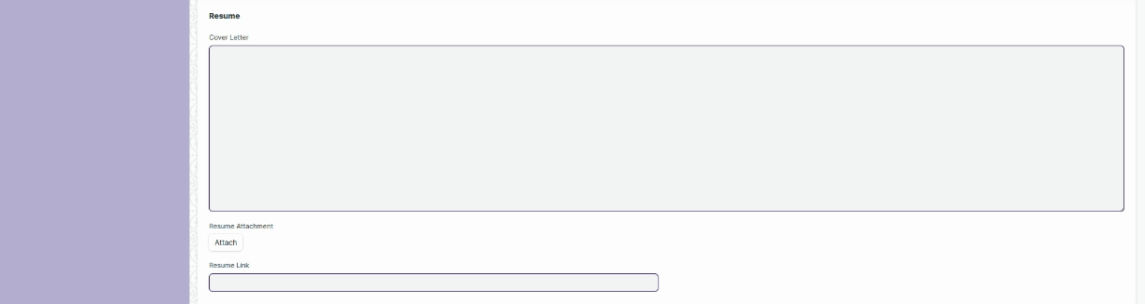

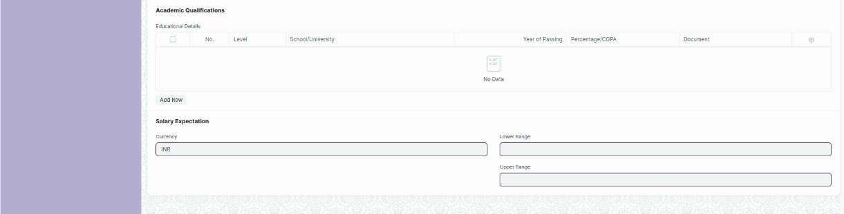

Figure 18 : Job Applicant Screen

**Field List:**

The following table describes the UI fields present in this screen :

|  |  |  |  |  |  |  |
| --- | --- | --- | --- | --- | --- | --- |
| **ID** | **Label** | **Type** | **Mandatory** | **Validation / Action** | **Remarks** | **R = Rename**  **N= New**  **D= Delete** |
| 1 | Applicant Name | Text | Yes |  |  |  |
| 2 | Email Address | Text | Yes |  |  |  |
| 3 | Phone Number | Text |  |  |  |  |
| 4 | Aadhar Card number | Text | Yes |  |  | N |
| 5 | Country | Link |  | Link to master screen Country |  |  |
| 6 | Job Opening | Link |  | Link Field to the screen Job Opening |  |  |
| 7 | Designation | Link |  | Link Field the master screen Designation. |  |  |
| 8 | Status | Drop down | Yes | Options :  Open  Replied  Rejected  Hold  Accepted |  |  |
| 9 | Source | Link |  | Link Field to screen job Applicant Source |  |  |
| 10 | Source Name | Link |  | Link Field to the master screen Employee |  |  |
| 11 | Previously Applied Application | Text |  |  |  | N |
| 12 | Employee Referral | Link |  | Link Field to the screen Employee Referral |  |  |
| 13 | Applicant Rating | Rating |  |  |  |  |
| 14 | Notes | Text |  |  |  |  |
| 15 | Cover Letter | Text |  |  |  |  |
| 16 | Resume Attachment | Attachment |  |  | Resume template should be uniform . |  |
| 17 | Resume Link | Text |  |  |  |  |
| 18 | Educational Details | Table | Yes |  | This table is described below | N |
| 19 | Previous Work History | Table |  |  | This table is described below | N |
| 20 | Currency | Currency |  |  |  |  |
| 21 | Lower Range | Number |  |  |  |  |
| 22 | Upper Range | Number |  |  |  |  |
| 23 | Exam Rounds Results | Table |  |  | This table is described below | N |

|  |  |  |  |  |  |  |
| --- | --- | --- | --- | --- | --- | --- |
| **Employee Education** | | | | | |  |
| **ID** | **Label** | **Type** | **Mandatory** | **Validation / Action** | **Remarks** | **R = Rename**  **N= New**  **D= Delete** |
| 1 | Level | Drop down |  | Options :  Graduate  Post Graduate  Under Graduate  Secondary Board (10th)  Higher Secondary (12th)  Diploma  ITI |  |  |
| 2 | School/University | Text |  |  |  |  |
| 3 | Year of Passing | Number |  |  |  |  |
| 4 | Percentage/CGPA | Number |  |  |  |  |
| 5 | Document | Attachment |  |  |  |  |
| **Employee External Work History** | | | | | |  |
| **ID** | **Label** | **Type** | **Mandatory** | **Validation / Action** | **Remarks** | **R = Rename**  **N= New**  **D= Delete** |
| 1 | Company | Text |  |  |  |  |
| 2 | Designation | Text |  |  |  |  |
| 3 | Salary | Currency |  |  |  |  |
| 4 | Address | Text |  |  |  |  |
| 5 | Contact | Text |  |  |  |  |
| 6 | Total Experience | Number |  |  |  |  |
| 7 | Document | Attachment |  |  |  |  |

|  |  |  |  |  |  |  |
| --- | --- | --- | --- | --- | --- | --- |
| **Exam Results** | | | | | |  |
| **ID** | **Label** | **Type** | **Mandatory** | **Validation / Action** | **Remarks** | **R = Rename**  **N= New**  **D= Delete** |
| 1 | Exam Round | Text |  |  |  |  |
| 2 | Result | Drop down |  | Option :  Pass  Failed |  |  |

**Users: Roles & Permission**

The following table describes the users and their roles and permissions for the screens :

|  |  |  |  |  |  |  |  |  |  |
| --- | --- | --- | --- | --- | --- | --- | --- | --- | --- |
| **ID** | **Role** | **Select** | **Read** | **Write** | **Create** | **Delete** | **Submit** | **Cancel** | **Amend** |
| 1 | HR Admin/Director Admin | Yes | Yes | Yes | Yes | Yes | NA | NA | NA |
| 2 | HR Manager | No | Yes | Yes | Yes | No | NA | NA | NA |
| 3 | HR Assistant | No | Yes | Yes | Yes | No | NA | NA | NA |
| 4 | Employee | No | Yes | Yes | Yes | No | NA | NA | NA |

### Recruitment Exam Declaration

**General Description**

The following table describes overall information about this screen:

|  |  |  |
| --- | --- | --- |
| **Description** | | 1. A screen where information regarding recruitment exams. |
| **Navigation** | | Home > HRMS > Recruitment > Recruitment Exam Declaration |
| **Pre-requisites** | | The system should have records in the following screen:   1. Job Opening 2. Job Applicant |
| **Existing Screen Name** | NA | | |
| **New Screen Name** | | Recruitment Exam Declaration |

**Screenshot**

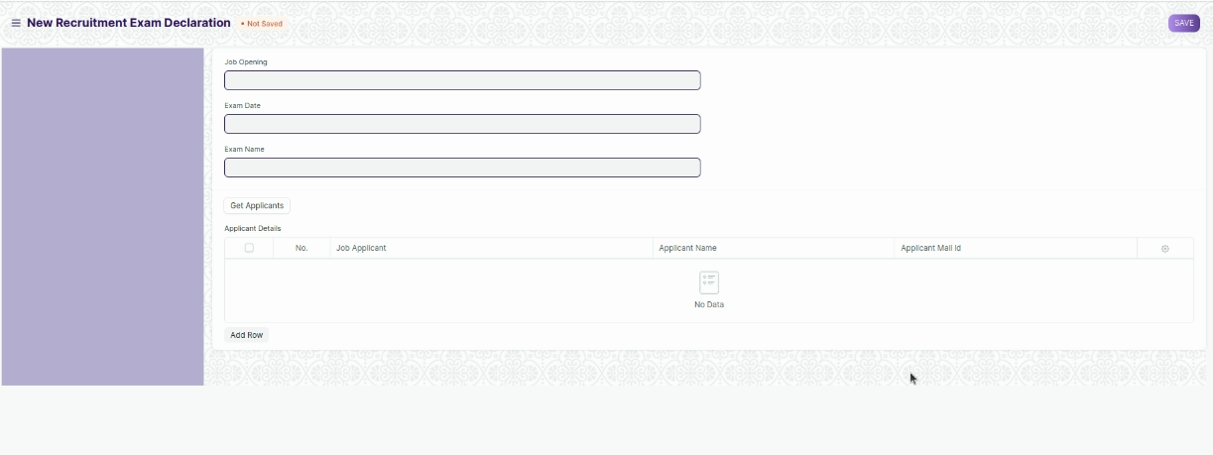

Figure 19 : Recruitment Exam Declaration Screen

**Field List**

The following table describes the UI fields present in this screen:

|  |  |  |  |  |  |  |
| --- | --- | --- | --- | --- | --- | --- |
| **ID** | **Label** | **Type** | **Mandatory** | **Validation / Action** | **Remarks** | **R = Rename**  **N= New**  **D= Delete** |
| 1 | Job Opening | Link | Yes | Link Field to the screen Job Opening |  |  |
| 2 | Exam Date | Date |  |  |  |  |
| 3 | Exam Name | Text |  |  |  |  |
| 4 | Get Applicants | Button |  | On Clicking the button , all the selected applicant for the particular job opening will be fetched. |  |  |
| 5 | Applicant Details | Table |  |  | This table is described below |  |

|  |  |  |  |  |  |  |
| --- | --- | --- | --- | --- | --- | --- |
| **Job Applicant Details** | | | | | |  |
| **ID** | **Label** | **Type** | **Mandatory** | **Validation / Action** | **Remarks** | **R = Rename**  **N= New**  **D= Delete** |
| 1 | Job Applicant | Text Field |  |  |  |  |
| 2 | Applicant Name | Text Field |  |  |  |  |
| 3 | Applicant Mail ID | Text Field |  |  |  |  |

**Note :**

After declaration of exam a mail will be triggered to all the applicants.

**Users: Roles & Permission**

The following table describes the users and their roles and permissions for the screens :

|  |  |  |  |  |  |  |  |  |  |
| --- | --- | --- | --- | --- | --- | --- | --- | --- | --- |
| **ID** | **Role** | **Select** | **Read** | **Write** | **Create** | **Delete** | **Submit** | **Cancel** | **Amend** |
| 1 | HR Admin/Director Admin | Yes | Yes | Yes | Yes | Yes | NA | NA | NA |
| 2 | HR Manager/CS | No | Yes | Yes | Yes | No | NA | NA | NA |
| 3 | HR Assistant | No | Yes | No | No | No | NA | NA | NA |
| 4 | Employee | No | Yes | No | No | No | NA | NA | NA |

### Recruitment Exam Center Allocation

**General Description**

The following table describes overall information about this screen:

|  |  |
| --- | --- |
| **Description** | 1. A screen where the information regarding exam location and date for the entrance exam is to be allotted and stored. |
| **Navigation** | Home > HRMS > Recruitment > Recruitment Exam Center Allocation |
| **Pre-requisites** | The system should have records in the following screen:   1. Job Applicant 2. Place Selection master |

|  |  |
| --- | --- |
| **Existing Screen Name** | NA |

|  |  |
| --- | --- |
| **New Screen Name** | Recruitment Center Allocation |

**Screenshot**

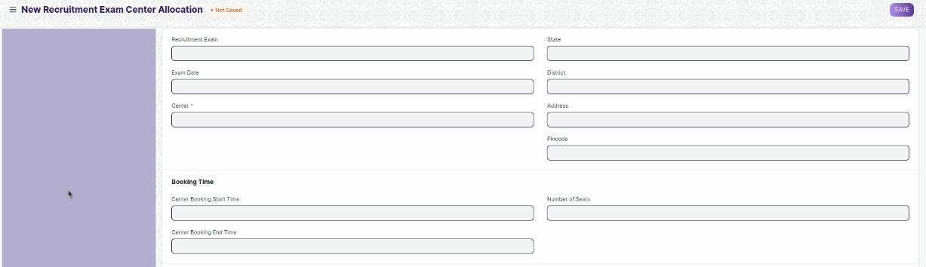



Figure 20 : Recruitment Center Allocation Screen

**Field List**

The following table describes the UI fields present in this screen :

|  |  |  |  |  |  |  |
| --- | --- | --- | --- | --- | --- | --- |
| **ID** | **Label** | **Type** | **Mandatory** | **Validation / Action** | **Remarks** | **R= Rename**  **N= New**  **D= Delete** |
| 1 | Recruitment Exam | Link | Yes | Links to Recruitment Exam Declaration Screen |  |  |
| 4 | Exam Date | Date | Yes | Auto Fetched after selection of Recruitment Exam Declaration |  |  |
| 5 | Centre | Link | Yes | Links to Place Selection Master |  |  |
| 6 | Centre Name | Text |  | Will be filled as per Place Selection Masters selected | Read Only Fields |  |
| 7 | Address | Text |  | Will be filled as per Place Selection Masters selected | Read Only Fields |  |
| 8 | District | Text |  | Will be filled as per Place Selection Masters selected | Read Only Fields |  |
| 9 | State | Text |  | Will be filled as per Place Selection Masters selected | Read Only Fields |  |
| 10 | Pin Code | Text |  | Will be filled as per Place Selection Masters selected | Read Only Fields |  |
| 11 | Centre Booking Time Start | Time | Yes |  |  |  |
| 12 | Centre Booking Time End | Time | Yes |  |  |  |
|  | Number of Seats | Number |  |  |  |  |
| 14 | Exam Slot Timings | Table | Yes | Will have data regarding exam slots for that specific day. Will need duplicate row validation with respect to exam time | For further details please check the tables below |  |

**Users: Roles & Permission**

The following table describes the users and their roles and permissions for the screens :

|  |  |  |  |  |  |  |  |  |  |
| --- | --- | --- | --- | --- | --- | --- | --- | --- | --- |
| **ID** | **Role** | **Select** | **Read** | **Write** | **Create** | **Delete** | **Submit** | **Cancel** | **Amend** |
| 1 | HR Admin/Director Admin | Yes | Yes | Yes | Yes | Yes | NA | NA | NA |
| 2 | HR Manager/CS | No | Yes | Yes | Yes | No | NA | NA | NA |
| 3 | HR Assistant | No | Yes | No | No | No | NA | NA | NA |
| 4 | Employee | No | Yes | No | No | No | NA | NA | NA |

### Recruitment Exam Admit Card Generation Tool

**General Description**

The following table describe overall information about this screen:

|  |  |
| --- | --- |
| **Description** | 1. A tool to generate multiple admit cards for applicants and also allots them a venue for the exam. |
| **Navigation** | Home > HRMS > Recruitment > Recruitment Exam Admit Card Generation Tool |
| **Pre-requisites** | The system should have records in the following screen:   1. Recruitment Exam Declaration 2. Place Selection master 3. Job Applicants |
| **Existing Screen Name** | NA |
| **New Screen Name** | Recruitment Exam Admit Card Generation Tool |

**Screenshot**

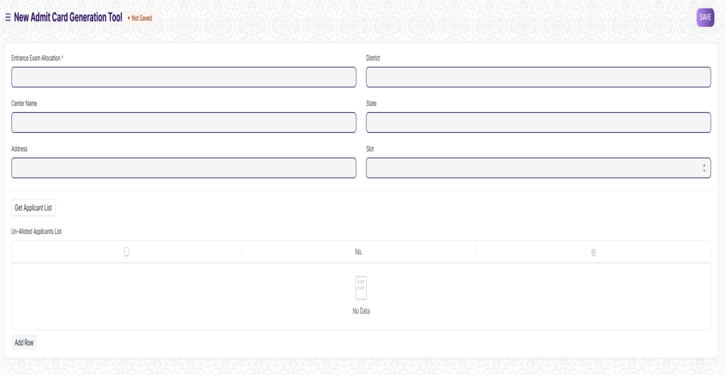

Figure 21 : Recruitment Exam Admit Card Generation Tool

**Field List**

The following table describes the UI fields present in this screen :

|  |  |  |  |  |  |  |
| --- | --- | --- | --- | --- | --- | --- |
| **ID** | **Label** | **Type** | **Mandatory** | **Validation / Action** | **Remarks** | **R= Rename**  **N= New**  **D= Delete** |
| 1 | Recruitment Exam Center Allocation | Link | Yes | Links to Recruitment Exam Center Allocation Screen |  |  |
| 2 | Centre Name | Text |  | Will be filled as per recruitment exam center allocation selected | Read Only Fields |  |
| 3 | Address | Text |  | Will be filled as per recruitment exam center allocation selected | Read Only Fields |  |
| 4 | District | Text |  | Will be filled as per recruitment exam center allocation selected | Read Only Fields |  |
| 5 | State | Text |  | Will be filled as per recruitment exam center allocation selected | Read Only Fields |  |
| 6 | Pin code | Text |  | Will be filled as per recruitment exam center allocation selected | Read Only Fields |  |
| 7 | Exam Date | Date |  | Will be filled as per recruitment exam center allocation selected | Read Only Fields |  |
| 8 | Slot | Dropdown |  | Will be filled as per recruitment exam center allocation selected Need to give a validation for slots, when they are filled those slots wont appear in the option |  |  |
| 9 | Get Job Applicant List | Button |  |  |  |  |
| 10 | Un-allotted Job Applicant List | Table |  | After clicking the above button, only those applicants information will be fetched who haven’t been allocated a venue and exam date | For further details regarding table Please check below |  |

|  |  |  |  |  |  |  |
| --- | --- | --- | --- | --- | --- | --- |
| **Un-allotted Job Applicant List** | | | | | | |
| **ID** | **Label** | **Type** | **Mandatory** | **Validation / Action** | **Remarks** | **R= Rename**  **N= New**  **D= Delete** |
| 1 | Job Applicant ID | Link | Yes | Links to Job Applicant Screen |  |  |
| 2 | Job Applicant Name | Text | Yes | Data in this field will be filled as per applicant ID | It will be a read only field |  |
| 3 | Gender | Text |  | Data in this field will be filled as per applicant ID | It will be a read only field |  |
| 5 | Mail id | Text |  |  |  |  |

**Users: Roles & Permission**

The following table describes the users and their roles and permissions for the screens

|  |  |  |  |  |  |  |  |  |  |
| --- | --- | --- | --- | --- | --- | --- | --- | --- | --- |
| **ID** | **Role** | **Select** | **Read** | **Write** | **Create** | **Delete** | **Submit** | **Cancel** | **Amend** |
| 1 | HR Admin/Director Admin | Yes | Yes | Yes | Yes | Yes | NA | NA | NA |
| 2 | HR Manager/CS | No | Yes | Yes | Yes | No | NA | NA | NA |
| 3 | HR Assistant | No | Yes | No | No | No | NA | NA | NA |
| 4 | Employee | No | Yes | No | No | No | NA | NA | NA |

### Recruitment Exam Admit Card Generation

**General Description**

The following table describe overall information about this screen:

|  |  |
| --- | --- |
| **Description** | 1. A screen which holds information of an individual job applicants admit card. 2. Most of the data in this field will be filled by the Recruitment Exam Admit Card Generation Tool |
| **Navigation** | Home > HRMS > Recruitment > Recruitment Exam Admit Card Generation |
| **Pre-requisites** | The system should have records in the following screen:   1. Recruitment Exam Declaration 2. Place Selection master 3. Job Applicants |
| **Existing Screen Name** | NA |
| **New Screen Name** | Recruitment Exam Admit Card Generation |

**Screenshot**

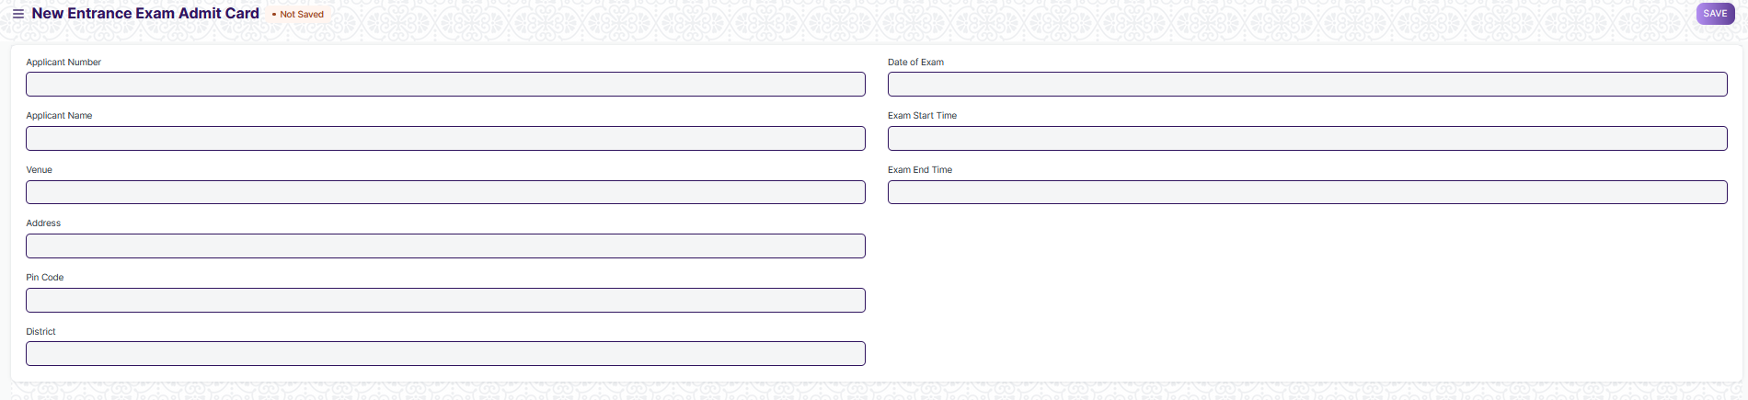

Figure 22 : Recruitment Exam Admit Card Generation Screen

**Field List**

The following table describes the UI fields present in this screen :

|  |  |  |  |  |  |  |
| --- | --- | --- | --- | --- | --- | --- |
| **ID** | **Label** | **Type** | **Mandatory** | **Validation / Action** | **Remarks** | **R= Rename**  **N= New**  **D= Delete** |
| 1 | Applicant Number | Link | Yes | Link Field to Job Applicant Screen. |  |  |
| 2 | Applicant Name | Text |  | Auto Fetched on selection of Job Applicant |  |  |
| 3 | Address | Text |  |  |  |  |
| 4 | Venue | Text |  |  |  |  |
| 5 | District | Text |  |  |  |  |
| 6 | Pin Code | Text |  |  |  |  |
| 7 | Date of Exam | Date |  |  |  |  |
| 8 | Exam Start Time | Time |  |  |  |  |
| 9 | Exam End Time | Time |  |  |  |  |

**Users: Roles & Permission**

The following table describes the users and their roles and permissions for the screens :

|  |  |  |  |  |  |  |  |  |  |
| --- | --- | --- | --- | --- | --- | --- | --- | --- | --- |
| **ID** | **Role** | **Select** | **Read** | **Write** | **Create** | **Delete** | **Submit** | **Cancel** | **Amend** |
| 1 | HR Admin/Director Admin | Yes | Yes | Yes | Yes | Yes | NA | NA | NA |
| 2 | HR Manager/CS | No | Yes | Yes | Yes | No | NA | NA | NA |
| 3 | HR Assistant | No | Yes | No | No | No | NA | NA | NA |
| 4 | Employee | No | Yes | No | No | No | NA | NA | NA |

### Recruitment Exam Result Declaration Tool

**General Description**

The following table describe overall information about this screen:

|  |  |
| --- | --- |
| **Description** | 1. A Recruitment Exam Result Declaration Tool declares the result of the applicant for different exam round in bulk. |
| **Navigation** | Home > HRMS > Recruitment > Recruitment Exam Result Declaration Tool |
| **Pre-requisites** | The system should have records in the following screen:   1. Recruitment Exam Declaration 2. Job Applicant |
| **Existing Screen Name** | NA |
| **New Screen Name** | Recruitment Exam Result Declaration Tool |

**Screenshot**

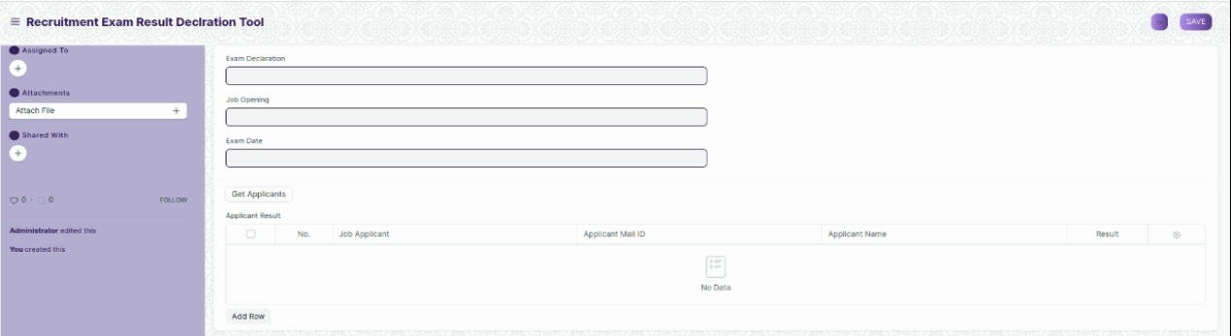

Figure 23 : Recruitment Exam Result Declaration Tool Screen

**Field List**

The following table describes the UI fields present in this screen :

|  |  |  |  |  |  |  |
| --- | --- | --- | --- | --- | --- | --- |
| **ID** | **Label** | **Type** | **Mandatory** | **Validation / Action** | **Remarks** | **R= Rename**  **N= New**  **D= Delete** |
| 1 | Exam Declaration | Link | Yes | Link Field to the screen Recruitment exam declaration |  |  |
| 2 | Job Opening | Text |  |  | Auto Fetched on selection of Exam Declaration |  |
| 3 | Exam Date | Text |  |  | Auto Fetched on selection of Exam Declaration |  |
| 4 | Get Applicants | Button |  |  |  |  |
| 5 | Applicant Result | Table |  |  | This table is described. |  |

|  |  |  |  |  |  |  |
| --- | --- | --- | --- | --- | --- | --- |
| **Applicant Result Details** | | | | | | |
| **ID** | **Label** | **Type** | **Mandatory** | **Validation / Action** | **Remarks** | **R= Rename**  **N= New**  **D= Delete** |
| 1 | Job Applicant | Link |  | Links to Job Applicant Screen |  |  |
| 2 | Applicant Name | Text |  | Data in this field will be filled as per applicant ID | It will be a read only field |  |
| 3 | Applicant Mail id | Text |  |  |  |  |
| 4 | Result | Drop down |  | Options :  Pass  Failed |  |  |

**Users: Roles & Permission**

The following table describes the users and their roles and permissions for the screens :

|  |  |  |  |  |  |  |  |  |  |
| --- | --- | --- | --- | --- | --- | --- | --- | --- | --- |
| **ID** | **Role** | **Select** | **Read** | **Write** | **Create** | **Delete** | **Submit** | **Cancel** | **Amend** |
| 1 | HR Admin/Director Admin | Yes | Yes | Yes | Yes | Yes | NA | NA | NA |
| 2 | HR Manager/CS | No | Yes | Yes | Yes | No | NA | NA | NA |
| 3 | HR Assistant | No | Yes | No | No | No | NA | NA | NA |
| 4 | Employee | No | Yes | No | No | No | NA | NA | NA |

### Recruitment Exam Result Declaration

**General Description**

The following table describe overall information about this screen:

|  |  |
| --- | --- |
| **Description** | 1. A Recruitment Exam Result Declaration Tool declares the result of the applicant for different exam round for particular candidate. |
| **Navigation** | Home > HRMS > Recruitment > Recruitment Exam Result Declaration Tool |
| **Pre-requisites** | The system should have records in the following screen:   1. Recruitment Exam Declaration 2. Job Applicant |
| **Existing Screen** | NA |
| **New Screen Name** | Recruitment Exam Result Declaration |

**Screenshot**

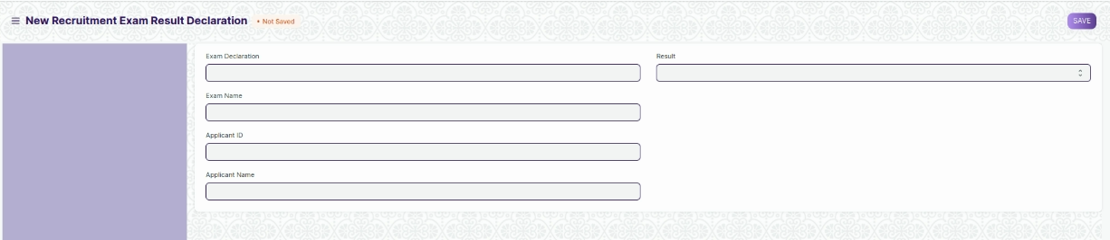

Figure 24: Recruitment Exam Result Declaration

**Field List**

The following table describes the UI fields present in this screen:

|  |  |  |  |  |  |  |
| --- | --- | --- | --- | --- | --- | --- |
| **ID** | **Label** | **Type** | **Mandatory** | **Validation / Action** | **Remarks** | **R= Rename**  **N= New**  **D= Delete** |
| 1 | Exam Declaration | Link | Yes | Link Field to the screen Recruitment exam declaration |  |  |
| 2 | Exam Name | Text |  | Auto Fetched on selection of Exam Declaration |  |  |
| 3 | Job Opening | Text |  | Auto Fetched on selection of Exam Declaration |  |  |
| 4 | Applicant ID | Link | Yes | Link Field to Job Applicant Screen . All the selected applicants of the selected job opening will be fetched in a dropdown. |  |  |
| 5 | Applicant Name | Text |  | Auto Fetched on selection of Job Applicant ID |  |  |
| 6 | Result | Dropdown |  | Option :  Pass  Fail |  |  |

**Users: Roles & Permission**

The following table describes the users and their roles and permissions for the screens:

|  |  |  |  |  |  |  |  |  |  |
| --- | --- | --- | --- | --- | --- | --- | --- | --- | --- |
| **ID** | **Role** | **Select** | **Read** | **Write** | **Create** | **Delete** | **Submit** | **Cancel** | **Amend** |
| 1 | HR Admin/Director Admin | Yes | Yes | Yes | Yes | Yes | NA | NA | NA |
| 2 | HR Manager/CS | No | Yes | Yes | Yes | No | NA | NA | NA |
| 3 | HR Assistant | No | Yes | No | No | No | NA | NA | NA |
| 4 | Employee | No | Yes | No | No | No | NA | NA | NA |

### Interview

**General Description**

The following table describes overall information about this screen:

|  |  |
| --- | --- |
| **Description** | 1. This screen is used to publish the interview result of a candidate. |
| **Navigation** | Home > HRMS > Recruitment > interview |
| **Pre-requisites** | The system should have records in the following screen:  1 Interview Type   1. Job Applicant 2. Interview Round |
| **Existing Screen Name** | Interview |
| **New Screen Name** | No change |

**Screenshot**

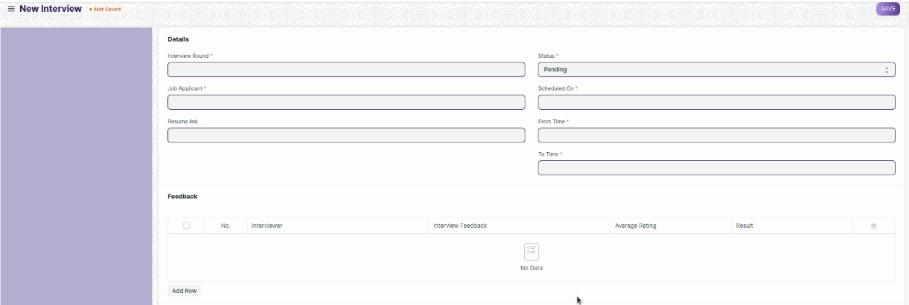

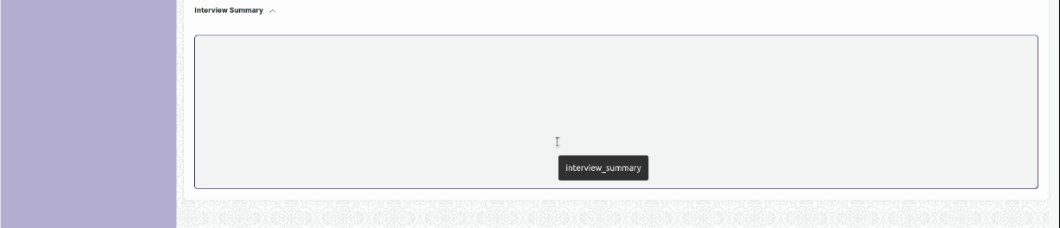

Figure 25: Interview Screen

**Field List**

The following table describes the UI fields present in this screen:

|  |  |  |  |  |  |  |
| --- | --- | --- | --- | --- | --- | --- |
| **ID** | **Label** | **Type** | **Mandatory** | **Validation / Action** | **Remarks** | **R= Rename**  **N= New**  **D= Delete** |
| 1 | Interview Round | Link | Yes | Link Field to the screen Interview Round |  |  |
| 2 | Job Applicant | Link | Yes | Link Field to the screen Job Applicant |  |  |
| 3 | Job Opening | Link |  | Link Field to the job Opening screen.Auto fetched on selection of Job Applicant. |  |  |
| 4 | Designation | Link |  | Link field to the screen designation. |  |  |
| 5 | Resume link | Text |  |  |  |  |
| 6 | Status | Checkbox | Yes | Option :  Pending  Under Review  Cleared  Rejected |  |  |
| 7 | Scheduled On | Date | Yes |  |  |  |
| 8 | From Time | Time | Yes |  |  |  |
| 9 | To Time | Time | Yes |  |  |  |
| 10 | Feedback | Child Table |  | This table is described below |  |  |
| 11 | Expected Average Rating | Rating |  |  |  |  |
| 12 | Obtained Average Rating | Rating |  |  |  |  |
| 13 | Interview Summary | Text |  |  |  |  |
| 14 | Reminded | Checkbox |  | If checked then a reminder will be set. |  |  |

|  |  |  |  |  |  |  |
| --- | --- | --- | --- | --- | --- | --- |
| **Interview Details** | | | | | | |
| **ID** | **Label** | **Type** | **Mandatory** | **Validation / Action** | **Remarks** | **R= Rename**  **N= New**  **D= Delete** |
| 1 | Interviewer | Link |  | Link Field to screen user |  |  |
| 2 | Interview Feedback | Link |  | Link Field to Interview Feedback Screen |  |  |
| 3 | Average Rating | Rating |  |  |  |  |
| 4 | Result | Drop down |  | Option :  Cleared  Rejected |  |  |
| 5 | Comments | Text |  |  |  |  |

**Users: Roles & Permission**

The following table describes the users and their roles and permissions for the screens :

|  |  |  |  |  |  |  |  |  |  |
| --- | --- | --- | --- | --- | --- | --- | --- | --- | --- |
| **ID** | **Role** | **Select** | **Read** | **Write** | **Create** | **Delete** | **Submit** | **Cancel** | **Amend** |
| 1 | HR Admin/Director Admin | Yes | Yes | Yes | Yes | Yes | Yes | Yes | Yes |
| 2 | HR Manager/CS | No | Yes | Yes | Yes | Yes | Yes | Yes | Yes |
| 3 | HR Assistant | No | Yes | No | No | No | No | No | No |
| 4 | Employee | No | Yes | No | No | No | No | No | No |

### Job Offer

**General Description**

The following table describes overall information about this screen:

|  |  |
| --- | --- |
| **Description** | 1. Job Offer is given to selected candidates after interview and selection which states the offered salary package, designation, grade, department, number of days entitled for leave among other information. |
| **Navigation** | Home > HRMS > Recruitment > interview |
| **Pre-requisites** | The system should have records in the following screen:   1. Staffing Plan 2. Job Applicant 3. Job Opening |
| **Existing Screen Name** | Job Offer |
| **New Screen Name** | No Change |

**Screenshot**

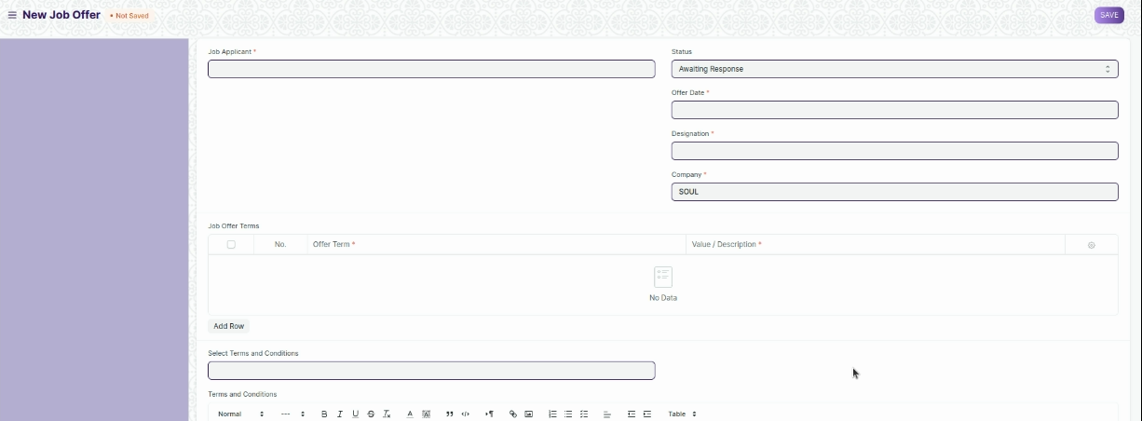

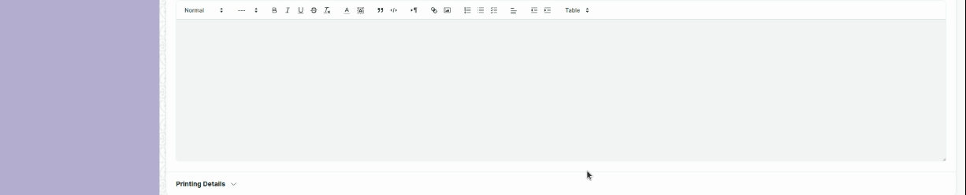

Figure 26 : Job Offer Screen

**Field List**

The following table describes the UI fields present in this screen :

|  |  |  |  |  |  |  |  |  |  |  |  |  |  |  |
| --- | --- | --- | --- | --- | --- | --- | --- | --- | --- | --- | --- | --- | --- | --- |
| **ID** | | | **Label** | **Type** | | | **Mandatory** | **Validation / Action** | | **Remarks** | | | **R= Rename**  **N= New**  **D= Delete** | |
| 1 | | | Job Applicant | Link | | | Yes | Link Field to Job Applicant Screen | |  | | |  | |
| 2 | | | Applicant Name | Text | | | Yes | Auto Fetched on selection of Job Applicant | |  | | |  | |
|  | | | Applicant Email Address | Text | | |  | Auto Fetched on selection of Job applicant | |  | | |  | |
| 3 | | | Status | Drop Down | | |  | Options :  Awaiting Response  Accepted  Rejected | |  | | |  | |
| 4 | | | Offer Date | Date | | | Yes |  | |  | | |  | |
| 5 | | | Designation | Link | | | Yes | Link Field to master screen designation | |  | | |  | |
| 6 | | | Employment Type | Link | | |  | Link Field to Employment Screen | |  | | | N | |
| 7 | | | Company | Link | | | Yes | Link Field to screen company | |  | | |  | |
| 8 | | | Upload Job Offer | Attachment | | | Yes |  | |  | | | N | |
| 9 | | | Upload result | Attachment | | |  |  | |  | | | N | |
| 10 | | | Upload other Document | Attachment | | |  |  | |  | | | N | |
| 11 | | | Job Offer Terms | table | | |  | This table is described below | |  | | |  | |
| 12 | | | Select Terms and Conditions | Link | | |  | Link Field to Terms and Conditions Screen | |  | | |  | |
| 13 | | | Terms and Conditions | Text | | |  |  | |  | | |  | |
| 14 | | | Letter Head | Link | | |  | Link Field to Letter Head Screen. | |  | | |  | |
| 15 | | | Print Heading | Link | | |  | Link Field to Printing Heading Screen. | |  | | |  | |
| **Job Offer Term** | | | | | | | | | | | | |
| **ID** | **Label** | | | **Type** | **Mandatory** | | | **Validation / Action** | | **Remarks** | **R= Rename**  **N= New**  **D= Delete** | |
| 1 | Offer Term | | | Link Field | Yes | | | Link Field to Offer Term Screen | |  |  | |
| 2 | Value/Description | | | Text Field | Yes | | |  | |  |  | |

**Users: Roles & Permission**

The following table describes the users and their roles and permissions for the screens :

|  |  |  |  |  |  |  |  |  |  |
| --- | --- | --- | --- | --- | --- | --- | --- | --- | --- |
| **ID** | **Role** | **Select** | **Read** | **Write** | **Create** | **Delete** | **Submit** | **Cancel** | **Amend** |
| 1 | HR Admin/Director Admin | Yes | Yes | Yes | Yes | Yes | Yes | Yes | Yes |
| 2 | HR Manager/CS | No | Yes | Yes | Yes | Yes | Yes | Yes | Yes |
| 3 | HR Assistant | No | Yes | No | No | No | No | No | No |
| 4 | Employee | No | Yes | No | No | No | No | No | No |

### Appointment Letter Template

**General Description**

The following table describes overall information about this screen:

|  |  |
| --- | --- |
| **Description** | 1. Appointment Letter Template is the standardized template used as the content of the appointment letter. |
| **Navigation** | Home > HRMS > Recruitment > Appointment Letter Template |
| **Pre-requisites** | NA |
| **Existing Screen Name** | Appointment Letter Template |
| **New Screen Name** | No Change |

**Screenshot**

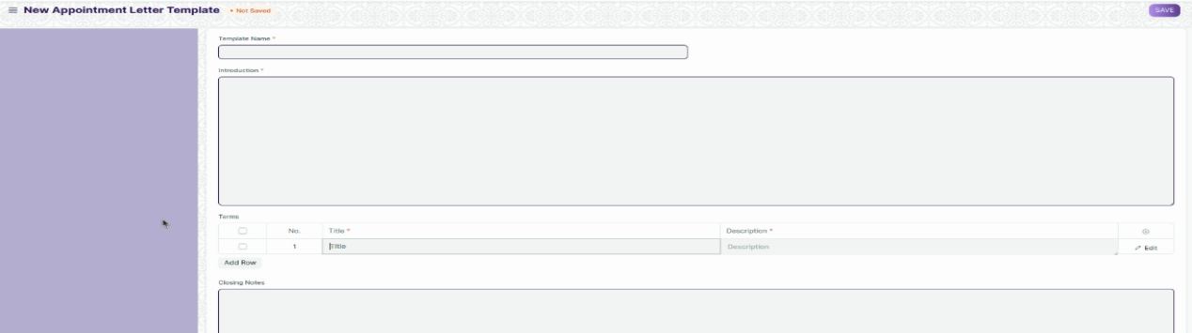

Figure 27: Appointment Letter Screen

**Field List**

The following table describes the UI fields present in this screen :

|  |  |  |  |  |  |  |  |  |  |  |  |  |  |
| --- | --- | --- | --- | --- | --- | --- | --- | --- | --- | --- | --- | --- | --- |
| **ID** | | | **Label** | **Type** | | | **Mandatory** | **Validation / Action** | | **Remarks** | | **R= Rename**  **N= New**  **D= Delete** | |
| 1 | | | Template Name | Text | | | Yes |  | |  | |  | |
| 2 | | | Introduction | Long Text | | | Yes |  | |  | |  | |
| 3 | | | Terms | Table | | | Yes | This table is described below | |  | |  | |
| 4 | | | Closing Notes | Text | | |  |  | |  | |  | |
| **Job Offer Term** | | | | | | | | | | | | | |
| **ID** | **Label** | | | **Type** | **Mandatory** | | | **Validation / Action** | | **Remarks** | | **R= Rename**  **N= New**  **D= Delete** | |
| 1 | Title | | | Text | Yes | | |  | |  | |  | |
| 2 | Description | | | Long Text | Yes | | |  | |  | |  | |

**Users: Roles & Permission**

The following table describes the users and their roles and permissions for the screens :

|  |  |  |  |  |  |  |  |  |  |
| --- | --- | --- | --- | --- | --- | --- | --- | --- | --- |
| **ID** | **Role** | **Select** | **Read** | **Write** | **Create** | **Delete** | **Submit** | **Cancel** | **Amend** |
| 1 | HR Admin/Director Admin | Yes | Yes | Yes | Yes | Yes | NA | NA | NA |
| 2 | HR Manager | No | Yes | Yes | Yes | Yes | NA | NA | NA |
| 3 | HR Assistant | No | Yes | No | No | No | NA | NA | NA |
| 4 | Employee | No | Yes | No | No | No | NA | NA | NA |

### Appointment Letter

**General Description**

The following table describes overall information about this screen:

|  |  |
| --- | --- |
| **Description** | 1. Appointment Letter is the letter written by the employer requesting the selected candidates to join in a specific position. |
| **Navigation** | Home > HRMS > Recruitment > Appointment Letter |
| **Pre-requisites** | The system should have records in the following screen:   1. Job Applicant |
| **Existing Screen Name** | Appointment Letter |
| **New Screen Name** | No Change |

**Screenshot**

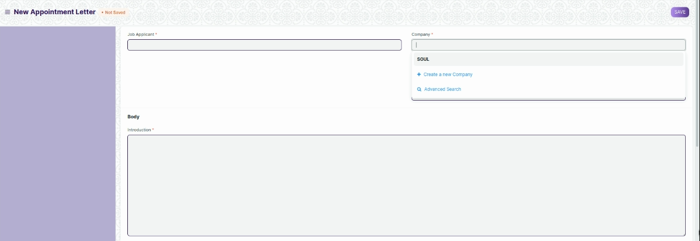

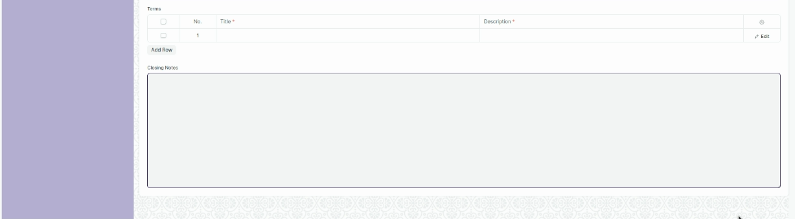

Figure 28 : Appointment Letter Screen

**Field List**

The following table describes the UI fields present in this screen :

|  |  |  |  |  |  |  |  |  |  |  |  |  |
| --- | --- | --- | --- | --- | --- | --- | --- | --- | --- | --- | --- | --- |
| **ID** | | **Label** | | **Type** | **Mandatory** | | **Validation / Action** | | **Remarks** | | | **R= Rename**  **N= New**  **D= Delete** |
| 1 | | Job Applicant | | Link | Yes | | Link Field to Job Applicant Screen | |  | | |  |
| 2 | | Applicant Name | | Text | Yes | | Auto Fetched on selection of Applicant | |  | | |  |
| 3 | | Company | | Link |  | | Link Field to company | |  | | |  |
| 4 | | Appointment Date | | Date | Yes | |  | |  | | |  |
| 5 | | Appointment Letter Template | | Link | Yes | | Link Field to Appointment Letter Template | |  | | |  |
| 6 | | Introduction | | Long Text | Yes | |  | |  | | |  |
| 7 | | Terms | | Table | Yes | | This table is described below | |  | | |  |
| 8 | | Closing Notes | | Text |  | |  | |  | | |  |
| **Appointment Letter Content** | | | | | | | | | | | | | |
| **ID** | **Label** | | **Type** | | | **Mandatory** | | **Validation / Action** | | **Remarks** | **R= Rename**  **N= New**  **D= Delete** | | |
| 1 | Title | | Text | | | Yes | |  | |  |  | | |
| 2 | Description | | Long Text | | | Yes | |  | |  |  | | |

**Users: Roles & Permission**

The following table describes the users and their roles and permissions for the screens :

|  |  |  |  |  |  |  |  |  |  |
| --- | --- | --- | --- | --- | --- | --- | --- | --- | --- |
| **ID** | **Role** | **Select** | **Read** | **Write** | **Create** | **Delete** | **Submit** | **Cancel** | **Amend** |
| 1 | HR Admin/Director Admin | Yes | Yes | Yes | Yes | Yes | NA | NA | NA |
| 2 | HR Manager | No | Yes | Yes | Yes | Yes | NA | NA | NA |
| 3 | HR Assistant | No | Yes | No | No | No | NA | NA | NA |
| 4 | Employee | No | No | No | No | No | NA | NA | NA |